Schema atg_filebetting.xsd

schema location: | C:\cvs-utveckling\tjlager3konf\modules\atgfilebet\src\xsd\atg_filebetting.xsd
attribute form default:
element form default: | qualified

Elements | Complex types
issuer | betcouponsType
 | DDCouponType
 | kombCouponType
 | LDCouponType
 | legType
 | legType20
 | raketCouponType
 | raketStageType
 | trioCouponType
 | tvillingCouponType
 | v3CouponType
 | v4CouponType
 | v5CouponType
 | v64CouponType
 | v65CouponType
 | v75CouponType
 | v86CouponType
 | VPCouponType

element issuer
diagram | 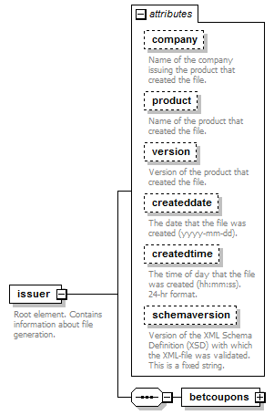
properties
  content | complex
children | betcoupons
attributes
  Name | Type | Use | Default | Fixed | annotation
  company | derived by: xs:string | optional
    documentation
    Name of the company issuing the product that created the file.
  product | derived by: xs:string | optional
    documentation
    Name of the product that created the file.
  version | derived by: xs:string | optional
    documentation
    Version of the product that created the file.
  createddate | xs:date | optional
    documentation
    The date that the file was created (yyyy-mm-dd).
  createdtime | xs:time | optional
    documentation
    The time of day that the file was created (hh:mm:ss). 24-hr format.
  schemaversion | xs:string |  |  | ATG File Betting XSD ver 1.8
    documentation
    Version of the XML Schema Definition (XSD) with which the XML-file was validated. This is a fixed string.
annotation
  documentation
  Root element. Contains information about file generation.
source | <xs:element name="issuer">  <xs:annotation>  <xs:documentation>Root element. Contains information about file generation.</xs:documentation>  </xs:annotation>  <xs:complexType>  <xs:sequence>  <xs:element name="betcoupons" type="betcouponsType"/>  </xs:sequence>  <xs:attribute name="company" use="optional">  <xs:annotation>  <xs:documentation>Name of the company issuing the product that created the file.</xs:documentation>  </xs:annotation>  <xs:simpleType>  <xs:restriction base="xs:string">  <xs:maxLength value="64"/>  </xs:restriction>  </xs:simpleType>  </xs:attribute>  <xs:attribute name="product" use="optional">  <xs:annotation>  <xs:documentation>Name of the product that created the file.</xs:documentation>  </xs:annotation>  <xs:simpleType>  <xs:restriction base="xs:string">  <xs:maxLength value="64"/>  </xs:restriction>  </xs:simpleType>  </xs:attribute>  <xs:attribute name="version" use="optional">  <xs:annotation>  <xs:documentation>Version of the product that created the file.</xs:documentation>  </xs:annotation>  <xs:simpleType>  <xs:restriction base="xs:string">  <xs:maxLength value="64"/>  </xs:restriction>  </xs:simpleType>  </xs:attribute>  <xs:attribute name="createddate" type="xs:date" use="optional">  <xs:annotation>  <xs:documentation>The date that the file was created (yyyy-mm-dd).</xs:documentation>  </xs:annotation>  </xs:attribute>  <xs:attribute name="createdtime" type="xs:time" use="optional">  <xs:annotation>  <xs:documentation>The time of day that the file was created (hh:mm:ss). 24-hr format.</xs:documentation>  </xs:annotation>  </xs:attribute>  <xs:attribute name="schemaversion" type="xs:string" fixed="ATG File Betting XSD ver 1.8">  <xs:annotation>  <xs:documentation>Version of the XML Schema Definition (XSD) with which the XML-file was validated. This is a fixed string.</xs:documentation>  </xs:annotation>  </xs:attribute>  </xs:complexType>  </xs:element>

attribute issuer/@company
type | restriction of xs:string
properties
  isRef | 0
  use | optional
facets
  Kind | Value | annotation
  maxLength | 64
annotation
  documentation
  Name of the company issuing the product that created the file.
source | <xs:attribute name="company" use="optional">  <xs:annotation>  <xs:documentation>Name of the company issuing the product that created the file.</xs:documentation>  </xs:annotation>  <xs:simpleType>  <xs:restriction base="xs:string">  <xs:maxLength value="64"/>  </xs:restriction>  </xs:simpleType>  </xs:attribute>

attribute issuer/@product
type | restriction of xs:string
properties
  isRef | 0
  use | optional
facets
  Kind | Value | annotation
  maxLength | 64
annotation
  documentation
  Name of the product that created the file.
source | <xs:attribute name="product" use="optional">  <xs:annotation>  <xs:documentation>Name of the product that created the file.</xs:documentation>  </xs:annotation>  <xs:simpleType>  <xs:restriction base="xs:string">  <xs:maxLength value="64"/>  </xs:restriction>  </xs:simpleType>  </xs:attribute>

attribute issuer/@version
type | restriction of xs:string
properties
  isRef | 0
  use | optional
facets
  Kind | Value | annotation
  maxLength | 64
annotation
  documentation
  Version of the product that created the file.
source | <xs:attribute name="version" use="optional">  <xs:annotation>  <xs:documentation>Version of the product that created the file.</xs:documentation>  </xs:annotation>  <xs:simpleType>  <xs:restriction base="xs:string">  <xs:maxLength value="64"/>  </xs:restriction>  </xs:simpleType>  </xs:attribute>

attribute issuer/@createddate
type | xs:date
properties
  isRef | 0
  use | optional
annotation
  documentation
  The date that the file was created (yyyy-mm-dd).
source | <xs:attribute name="createddate" type="xs:date" use="optional">  <xs:annotation>  <xs:documentation>The date that the file was created (yyyy-mm-dd).</xs:documentation>  </xs:annotation>  </xs:attribute>

attribute issuer/@createdtime
type | xs:time
properties
  isRef | 0
  use | optional
annotation
  documentation
  The time of day that the file was created (hh:mm:ss). 24-hr format.
source | <xs:attribute name="createdtime" type="xs:time" use="optional">  <xs:annotation>  <xs:documentation>The time of day that the file was created (hh:mm:ss). 24-hr format.</xs:documentation>  </xs:annotation>  </xs:attribute>

attribute issuer/@schemaversion
type | xs:string
properties
  isRef | 0
  fixed | ATG File Betting XSD ver 1.8
annotation
  documentation
  Version of the XML Schema Definition (XSD) with which the XML-file was validated. This is a fixed string.
source | <xs:attribute name="schemaversion" type="xs:string" fixed="ATG File Betting XSD ver 1.8">  <xs:annotation>  <xs:documentation>Version of the XML Schema Definition (XSD) with which the XML-file was validated. This is a fixed string.</xs:documentation>  </xs:annotation>  </xs:attribute>

element issuer/betcoupons
diagram | 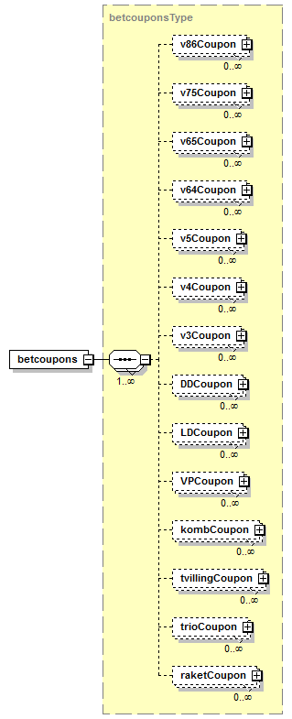
type | betcouponsType
properties
  isRef | 0
  content | complex
children | v86Coupon v75Coupon v65Coupon v64Coupon v5Coupon v4Coupon v3Coupon DDCoupon LDCoupon VPCoupon kombCoupon tvillingCoupon trioCoupon raketCoupon
source | <xs:element name="betcoupons" type="betcouponsType"/>

complexType betcouponsType
diagram | 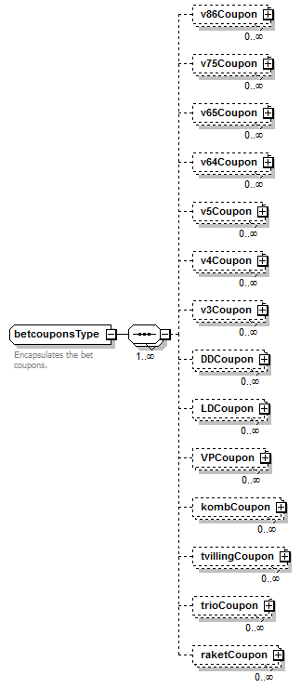
children | v86Coupon v75Coupon v65Coupon v64Coupon v5Coupon v4Coupon v3Coupon DDCoupon LDCoupon VPCoupon kombCoupon tvillingCoupon trioCoupon raketCoupon
used by
  element | issuer/betcoupons
annotation
  documentation
  Encapsulates the bet coupons.
source | <xs:complexType name="betcouponsType">  <xs:annotation>  <xs:documentation>Encapsulates the bet coupons.</xs:documentation>  </xs:annotation>  <xs:sequence maxOccurs="unbounded">  <xs:element name="v86Coupon" type="v86CouponType" minOccurs="0" maxOccurs="unbounded"/>  <xs:element name="v75Coupon" type="v75CouponType" minOccurs="0" maxOccurs="unbounded"/>  <xs:element name="v65Coupon" type="v65CouponType" minOccurs="0" maxOccurs="unbounded"/>  <xs:element name="v64Coupon" type="v64CouponType" minOccurs="0" maxOccurs="unbounded"/>  <xs:element name="v5Coupon" type="v5CouponType" minOccurs="0" maxOccurs="unbounded"/>  <xs:element name="v4Coupon" type="v4CouponType" minOccurs="0" maxOccurs="unbounded"/>  <xs:element name="v3Coupon" type="v3CouponType" minOccurs="0" maxOccurs="unbounded"/>  <xs:element name="DDCoupon" type="DDCouponType" minOccurs="0" maxOccurs="unbounded"/>  <xs:element name="LDCoupon" type="LDCouponType" minOccurs="0" maxOccurs="unbounded"/>  <xs:element name="VPCoupon" type="VPCouponType" minOccurs="0" maxOccurs="unbounded"/>  <xs:element name="kombCoupon" type="kombCouponType" minOccurs="0" maxOccurs="unbounded"/>  <xs:element name="tvillingCoupon" type="tvillingCouponType" minOccurs="0" maxOccurs="unbounded"/>  <xs:element name="trioCoupon" type="trioCouponType" minOccurs="0" maxOccurs="unbounded"/>  <xs:element name="raketCoupon" type="raketCouponType" minOccurs="0" maxOccurs="unbounded"/>  </xs:sequence>  </xs:complexType>

element betcouponsType/v86Coupon
diagram | 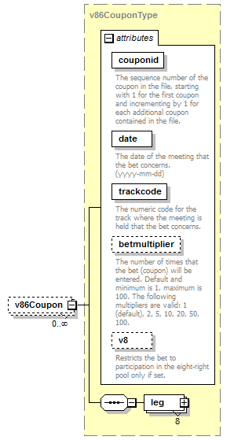
type | v86CouponType
properties
  isRef | 0
  minOcc | 0
  maxOcc | unbounded
  content | complex
children | leg
attributes
  Name | Type | Use | Default | Fixed | annotation
  couponid | derived by: xs:integer | required
    documentation
    The sequence number of the coupon in the file, starting with 1 for the first coupon and incrementing by 1 for each additional coupon contained in the file.
  date | xs:date | required
    documentation
    The date of the meeting that the bet concerns. (yyyy-mm-dd)
  trackcode | derived by: xs:integer | required
    documentation
    The numeric code for the track where the meeting is held that the bet concerns.
  betmultiplier | derived by: xs:integer | optional | 1
    documentation
    The number of times that the bet (coupon) will be entered. Default and minimum is 1, maximum is 100. The following multipliers are valid: 1 (default), 2, 5, 10, 20, 50, 100.
  v8 | xs:boolean | optional | 0
    documentation
    Restricts the bet to participation in the eight-right pool only if set.
source | <xs:element name="v86Coupon" type="v86CouponType" minOccurs="0" maxOccurs="unbounded"/>

element betcouponsType/v75Coupon
diagram | 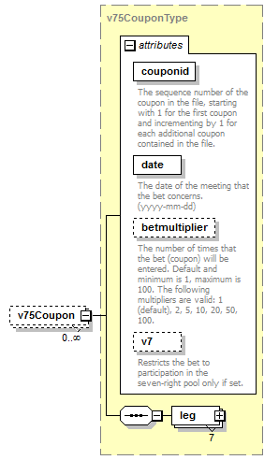
type | v75CouponType
properties
  isRef | 0
  minOcc | 0
  maxOcc | unbounded
  content | complex
children | leg
attributes
  Name | Type | Use | Default | Fixed | annotation
  couponid | derived by: xs:integer | required
    documentation
    The sequence number of the coupon in the file, starting with 1 for the first coupon and incrementing by 1 for each additional coupon contained in the file.
  date | xs:date | required
    documentation
    The date of the meeting that the bet concerns. (yyyy-mm-dd)
  betmultiplier | derived by: xs:integer | optional | 1
    documentation
    The number of times that the bet (coupon) will be entered. Default and minimum is 1, maximum is 100. The following multipliers are valid: 1 (default), 2, 5, 10, 20, 50, 100.
  v7 | xs:boolean | optional | 0
    documentation
    Restricts the bet to participation in the seven-right pool only if set.
source | <xs:element name="v75Coupon" type="v75CouponType" minOccurs="0" maxOccurs="unbounded"/>

element betcouponsType/v65Coupon
diagram | 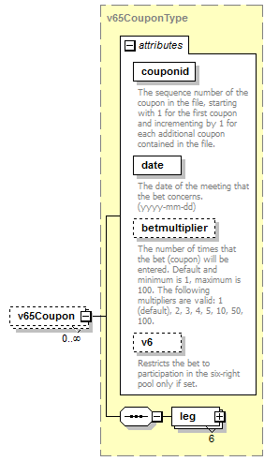
type | v65CouponType
properties
  isRef | 0
  minOcc | 0
  maxOcc | unbounded
  content | complex
children | leg
attributes
  Name | Type | Use | Default | Fixed | annotation
  couponid | derived by: xs:integer | required
    documentation
    The sequence number of the coupon in the file, starting with 1 for the first coupon and incrementing by 1 for each additional coupon contained in the file.
  date | xs:date | required
    documentation
    The date of the meeting that the bet concerns. (yyyy-mm-dd)
  betmultiplier | derived by: xs:integer | optional | 1
    documentation
    The number of times that the bet (coupon) will be entered. Default and minimum is 1, maximum is 100. The following multipliers are valid: 1 (default), 2, 3, 4, 5, 10, 50, 100.
  v6 | xs:boolean | optional | 0
    documentation
    Restricts the bet to participation in the six-right pool only if set.
source | <xs:element name="v65Coupon" type="v65CouponType" minOccurs="0" maxOccurs="unbounded"/>

element betcouponsType/v64Coupon
diagram | 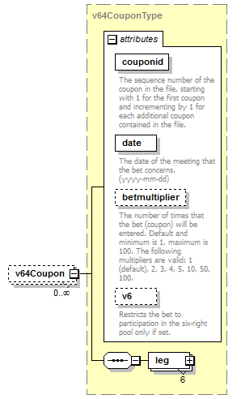
type | v64CouponType
properties
  isRef | 0
  minOcc | 0
  maxOcc | unbounded
  content | complex
children | leg
attributes
  Name | Type | Use | Default | Fixed | annotation
  couponid | derived by: xs:integer | required
    documentation
    The sequence number of the coupon in the file, starting with 1 for the first coupon and incrementing by 1 for each additional coupon contained in the file.
  date | xs:date | required
    documentation
    The date of the meeting that the bet concerns. (yyyy-mm-dd)
  betmultiplier | derived by: xs:integer | optional | 1
    documentation
    The number of times that the bet (coupon) will be entered. Default and minimum is 1, maximum is 100. The following multipliers are valid: 1 (default), 2, 3, 4, 5, 10, 50, 100.
  v6 | xs:boolean | optional | 0
    documentation
    Restricts the bet to participation in the six-right pool only if set.
source | <xs:element name="v64Coupon" type="v64CouponType" minOccurs="0" maxOccurs="unbounded"/>

element betcouponsType/v5Coupon
diagram | 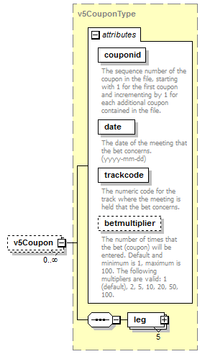
type | v5CouponType
properties
  isRef | 0
  minOcc | 0
  maxOcc | unbounded
  content | complex
children | leg
attributes
  Name | Type | Use | Default | Fixed | annotation
  couponid | derived by: xs:integer | required
    documentation
    The sequence number of the coupon in the file, starting with 1 for the first coupon and incrementing by 1 for each additional coupon contained in the file.
  date | xs:date | required
    documentation
    The date of the meeting that the bet concerns. (yyyy-mm-dd)
  trackcode | derived by: xs:integer | required
    documentation
    The numeric code for the track where the meeting is held that the bet concerns.
  betmultiplier | derived by: xs:integer | optional | 1
    documentation
    The number of times that the bet (coupon) will be entered. Default and minimum is 1, maximum is 100. The following multipliers are valid: 1 (default), 2, 5, 10, 20, 50, 100.
source | <xs:element name="v5Coupon" type="v5CouponType" minOccurs="0" maxOccurs="unbounded"/>

element betcouponsType/v4Coupon
diagram | 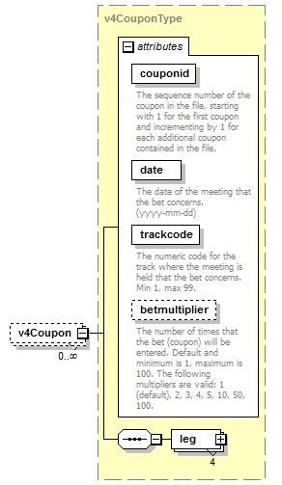
type | v4CouponType
properties
  isRef | 0
  minOcc | 0
  maxOcc | unbounded
  content | complex
children | leg
attributes
  Name | Type | Use | Default | Fixed | annotation
  couponid | derived by: xs:integer | required
    documentation
    The sequence number of the coupon in the file, starting with 1 for the first coupon and incrementing by 1 for each additional coupon contained in the file.
  date | xs:date | required
    documentation
    The date of the meeting that the bet concerns. (yyyy-mm-dd)
  trackcode | derived by: xs:integer | required
    documentation
    The numeric code for the track where the meeting is held that the bet concerns. Min 1, max 99.
  betmultiplier | derived by: xs:integer | optional | 1
    documentation
    The number of times that the bet (coupon) will be entered. Default and minimum is 1, maximum is 100. The following multipliers are valid: 1 (default), 2, 3, 4, 5, 10, 50, 100.
source | <xs:element name="v4Coupon" type="v4CouponType" minOccurs="0" maxOccurs="unbounded"/>

element betcouponsType/v3Coupon
diagram | 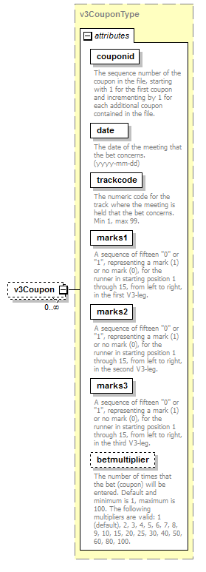
type | v3CouponType
properties
  isRef | 0
  minOcc | 0
  maxOcc | unbounded
  content | complex
attributes
  Name | Type | Use | Default | Fixed | annotation
  couponid | derived by: xs:integer | required
    documentation
    The sequence number of the coupon in the file, starting with 1 for the first coupon and incrementing by 1 for each additional coupon contained in the file.
  date | xs:date | required
    documentation
    The date of the meeting that the bet concerns. (yyyy-mm-dd)
  trackcode | derived by: xs:integer | required
    documentation
    The numeric code for the track where the meeting is held that the bet concerns. Min 1, max 99.
  marks1 | derived by: xs:string | required
    documentation
    A sequence of fifteen "0" or "1", representing a mark (1) or no mark (0), for the runner in starting position 1 through 15, from left to right, in the first V3-leg.
  marks2 | derived by: xs:string | required
    documentation
    A sequence of fifteen "0" or "1", representing a mark (1) or no mark (0), for the runner in starting position 1 through 15, from left to right, in the second V3-leg.
  marks3 | derived by: xs:string | required
    documentation
    A sequence of fifteen "0" or "1", representing a mark (1) or no mark (0), for the runner in starting position 1 through 15, from left to right, in the third V3-leg.
  betmultiplier | derived by: xs:integer | optional | 1
    documentation
    The number of times that the bet (coupon) will be entered. Default and minimum is 1, maximum is 100. The following multipliers are valid: 1 (default), 2, 3, 4, 5, 6, 7, 8, 9, 10, 15, 20, 25, 30, 40, 50, 60, 80, 100.
source | <xs:element name="v3Coupon" type="v3CouponType" minOccurs="0" maxOccurs="unbounded"/>

element betcouponsType/DDCoupon
diagram | 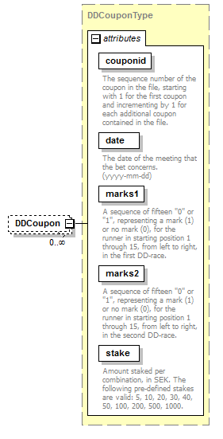
type | DDCouponType
properties
  isRef | 0
  minOcc | 0
  maxOcc | unbounded
  content | complex
attributes
  Name | Type | Use | Default | Fixed | annotation
  couponid | derived by: xs:integer | required
    documentation
    The sequence number of the coupon in the file, starting with 1 for the first coupon and incrementing by 1 for each additional coupon contained in the file.
  date | xs:date | required
    documentation
    The date of the meeting that the bet concerns. (yyyy-mm-dd)
  marks1 | derived by: xs:string | required
    documentation
    A sequence of fifteen "0" or "1", representing a mark (1) or no mark (0), for the runner in starting position 1 through 15, from left to right, in the first DD-race.
  marks2 | derived by: xs:string | required
    documentation
    A sequence of fifteen "0" or "1", representing a mark (1) or no mark (0), for the runner in starting position 1 through 15, from left to right, in the second DD-race.
  stake | derived by: xs:integer | required
    documentation
    Amount staked per combination, in SEK. The following pre-defined stakes are valid: 5, 10, 20, 30, 40, 50, 100, 200, 500, 1000.
source | <xs:element name="DDCoupon" type="DDCouponType" minOccurs="0" maxOccurs="unbounded"/>

element betcouponsType/LDCoupon
diagram | 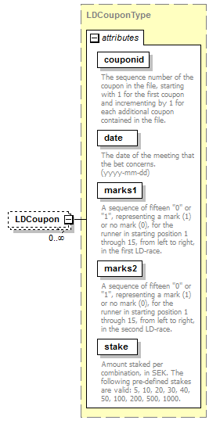
type | LDCouponType
properties
  isRef | 0
  minOcc | 0
  maxOcc | unbounded
  content | complex
attributes
  Name | Type | Use | Default | Fixed | annotation
  couponid | derived by: xs:integer | required
    documentation
    The sequence number of the coupon in the file, starting with 1 for the first coupon and incrementing by 1 for each additional coupon contained in the file.
  date | xs:date | required
    documentation
    The date of the meeting that the bet concerns. (yyyy-mm-dd)
  marks1 | derived by: xs:string | required
    documentation
    A sequence of fifteen "0" or "1", representing a mark (1) or no mark (0), for the runner in starting position 1 through 15, from left to right, in the first LD-race.
  marks2 | derived by: xs:string | required
    documentation
    A sequence of fifteen "0" or "1", representing a mark (1) or no mark (0), for the runner in starting position 1 through 15, from left to right, in the second LD-race.
  stake | derived by: xs:integer | required
    documentation
    Amount staked per combination, in SEK. The following pre-defined stakes are valid: 5, 10, 20, 30, 40, 50, 100, 200, 500, 1000.
source | <xs:element name="LDCoupon" type="LDCouponType" minOccurs="0" maxOccurs="unbounded"/>

element betcouponsType/VPCoupon
diagram | 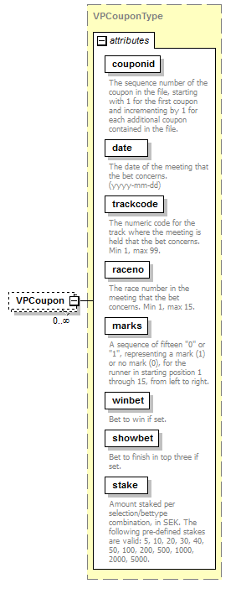
type | VPCouponType
properties
  isRef | 0
  minOcc | 0
  maxOcc | unbounded
  content | complex
attributes
  Name | Type | Use | Default | Fixed | annotation
  couponid | derived by: xs:integer | required
    documentation
    The sequence number of the coupon in the file, starting with 1 for the first coupon and incrementing by 1 for each additional coupon contained in the file.
  date | xs:date | required
    documentation
    The date of the meeting that the bet concerns. (yyyy-mm-dd)
  trackcode | derived by: xs:integer | required
    documentation
    The numeric code for the track where the meeting is held that the bet concerns. Min 1, max 99.
  raceno | derived by: xs:integer | required
    documentation
    The race number in the meeting that the bet concerns. Min 1, max 15.
  marks | derived by: xs:string | required
    documentation
    A sequence of fifteen "0" or "1", representing a mark (1) or no mark (0), for the runner in starting position 1 through 15, from left to right.
  winbet | xs:boolean | required
    documentation
    Bet to win if set.
  showbet | xs:boolean | required
    documentation
    Bet to finish in top three if set.
  stake | derived by: xs:integer | required
    documentation
    Amount staked per selection/bettype combination, in SEK. The following pre-defined stakes are valid: 5, 10, 20, 30, 40, 50, 100, 200, 500, 1000, 2000, 5000.
source | <xs:element name="VPCoupon" type="VPCouponType" minOccurs="0" maxOccurs="unbounded"/>

element betcouponsType/kombCoupon
diagram | 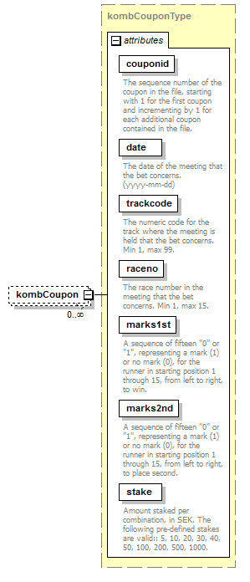
type | kombCouponType
properties
  isRef | 0
  minOcc | 0
  maxOcc | unbounded
  content | complex
attributes
  Name | Type | Use | Default | Fixed | annotation
  couponid | derived by: xs:integer | required
    documentation
    The sequence number of the coupon in the file, starting with 1 for the first coupon and incrementing by 1 for each additional coupon contained in the file.
  date | xs:date | required
    documentation
    The date of the meeting that the bet concerns. (yyyy-mm-dd)
  trackcode | derived by: xs:integer | required
    documentation
    The numeric code for the track where the meeting is held that the bet concerns. Min 1, max 99.
  raceno | derived by: xs:integer | required
    documentation
    The race number in the meeting that the bet concerns. Min 1, max 15.
  marks1st | derived by: xs:string | required
    documentation
    A sequence of fifteen "0" or "1", representing a mark (1) or no mark (0), for the runner in starting position 1 through 15, from left to right, to win.
  marks2nd | derived by: xs:string | required
    documentation
    A sequence of fifteen "0" or "1", representing a mark (1) or no mark (0), for the runner in starting position 1 through 15, from left to right, to place second.
  stake | derived by: xs:integer | required
    documentation
    Amount staked per combination, in SEK. The following pre-defined stakes are valid:: 5, 10, 20, 30, 40, 50, 100, 200, 500, 1000.
source | <xs:element name="kombCoupon" type="kombCouponType" minOccurs="0" maxOccurs="unbounded"/>

element betcouponsType/tvillingCoupon
diagram | 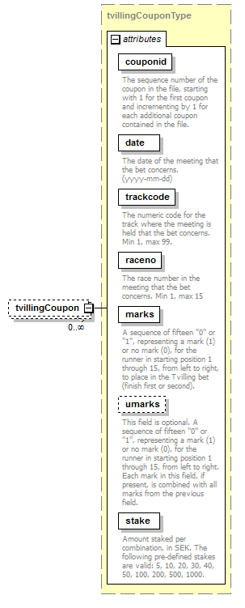
type | tvillingCouponType
properties
  isRef | 0
  minOcc | 0
  maxOcc | unbounded
  content | complex
attributes
  Name | Type | Use | Default | Fixed | annotation
  couponid | derived by: xs:integer | required
    documentation
    The sequence number of the coupon in the file, starting with 1 for the first coupon and incrementing by 1 for each additional coupon contained in the file.
  date | xs:date | required
    documentation
    The date of the meeting that the bet concerns. (yyyy-mm-dd)
  trackcode | derived by: xs:integer | required
    documentation
    The numeric code for the track where the meeting is held that the bet concerns. Min 1, max 99.
  raceno | derived by: xs:integer | required
    documentation
    The race number in the meeting that the bet concerns. Min 1, max 15
  marks | derived by: xs:string | required
    documentation
    A sequence of fifteen "0" or "1", representing a mark (1) or no mark (0), for the runner in starting position 1 through 15, from left to right, to place in the Tvilling bet (finish first or second).
  umarks | derived by: xs:string | optional
    documentation
    This field is optional. A sequence of fifteen "0" or "1", representing a mark (1) or no mark (0), for the runner in starting position 1 through 15, from left to right. Each mark in this field, if present, is combined with all marks from the previous field.
  stake | derived by: xs:integer | required
    documentation
    Amount staked per combination, in SEK. The following pre-defined stakes are valid: 5, 10, 20, 30, 40, 50, 100, 200, 500, 1000.
source | <xs:element name="tvillingCoupon" type="tvillingCouponType" minOccurs="0" maxOccurs="unbounded"/>

element betcouponsType/trioCoupon
diagram | 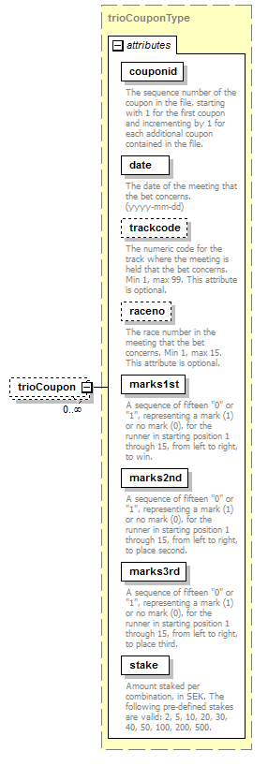
type | trioCouponType
properties
  isRef | 0
  minOcc | 0
  maxOcc | unbounded
  content | complex
attributes
  Name | Type | Use | Default | Fixed | annotation
  couponid | derived by: xs:integer | required
    documentation
    The sequence number of the coupon in the file, starting with 1 for the first coupon and incrementing by 1 for each additional coupon contained in the file.
  date | xs:date | required
    documentation
    The date of the meeting that the bet concerns. (yyyy-mm-dd)
  trackcode | derived by: xs:integer | optional
    documentation
    The numeric code for the track where the meeting is held that the bet concerns. Min 1, max 99. This attribute is optional.
  raceno | derived by: xs:integer | optional
    documentation
    The race number in the meeting that the bet concerns. Min 1, max 15. This attribute is optional.
  marks1st | derived by: xs:string | required
    documentation
    A sequence of fifteen "0" or "1", representing a mark (1) or no mark (0), for the runner in starting position 1 through 15, from left to right, to win.
  marks2nd | derived by: xs:string | required
    documentation
    A sequence of fifteen "0" or "1", representing a mark (1) or no mark (0), for the runner in starting position 1 through 15, from left to right, to place second.
  marks3rd | derived by: xs:string | required
    documentation
    A sequence of fifteen "0" or "1", representing a mark (1) or no mark (0), for the runner in starting position 1 through 15, from left to right, to place third.
  stake | derived by: xs:integer | required
    documentation
    Amount staked per combination, in SEK. The following pre-defined stakes are valid: 2, 5, 10, 20, 30, 40, 50, 100, 200, 500.
source | <xs:element name="trioCoupon" type="trioCouponType" minOccurs="0" maxOccurs="unbounded"/>

element betcouponsType/raketCoupon
diagram | 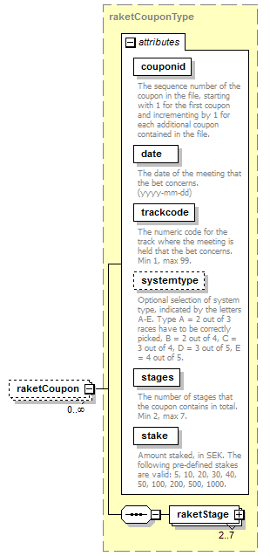
type | raketCouponType
properties
  isRef | 0
  minOcc | 0
  maxOcc | unbounded
  content | complex
children | raketStage
attributes
  Name | Type | Use | Default | Fixed | annotation
  couponid | derived by: xs:integer | required
    documentation
    The sequence number of the coupon in the file, starting with 1 for the first coupon and incrementing by 1 for each additional coupon contained in the file.
  date | xs:date | required
    documentation
    The date of the meeting that the bet concerns. (yyyy-mm-dd)
  trackcode | derived by: xs:integer | required
    documentation
    The numeric code for the track where the meeting is held that the bet concerns. Min 1, max 99.
  systemtype | derived by: xs:string | optional
    documentation
    Optional selection of system type, indicated by the letters A-E. Type A = 2 out of 3 races have to be correctly picked, B = 2 out of 4, C = 3 out of 4, D = 3 out of 5, E = 4 out of 5.
  stages | derived by: xs:integer | required
    documentation
    The number of stages that the coupon contains in total. Min 2, max 7.
  stake | derived by: xs:integer | required
    documentation
    Amount staked, in SEK. The following pre-defined stakes are valid: 5, 10, 20, 30, 40, 50, 100, 200, 500, 1000.
source | <xs:element name="raketCoupon" type="raketCouponType" minOccurs="0" maxOccurs="unbounded"/>

complexType DDCouponType
diagram | 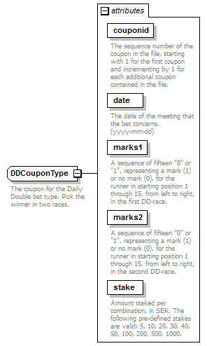
used by
  element | betcouponsType/DDCoupon
attributes
  Name | Type | Use | Default | Fixed | annotation
  couponid | derived by: xs:integer | required
    documentation
    The sequence number of the coupon in the file, starting with 1 for the first coupon and incrementing by 1 for each additional coupon contained in the file.
  date | xs:date | required
    documentation
    The date of the meeting that the bet concerns. (yyyy-mm-dd)
  marks1 | derived by: xs:string | required
    documentation
    A sequence of fifteen "0" or "1", representing a mark (1) or no mark (0), for the runner in starting position 1 through 15, from left to right, in the first DD-race.
  marks2 | derived by: xs:string | required
    documentation
    A sequence of fifteen "0" or "1", representing a mark (1) or no mark (0), for the runner in starting position 1 through 15, from left to right, in the second DD-race.
  stake | derived by: xs:integer | required
    documentation
    Amount staked per combination, in SEK. The following pre-defined stakes are valid: 5, 10, 20, 30, 40, 50, 100, 200, 500, 1000.
annotation
  documentation
  The coupon for the Daily Double bet type. Pick the winner in two races.
source | <xs:complexType name="DDCouponType">  <xs:annotation>  <xs:documentation>The coupon for the Daily Double bet type. Pick the winner in two races.</xs:documentation>  </xs:annotation>  <xs:attribute name="couponid" use="required">  <xs:annotation>  <xs:documentation>The sequence number of the coupon in the file, starting with 1 for the first coupon and incrementing by 1 for each additional coupon contained in the file.</xs:documentation>  </xs:annotation>  <xs:simpleType>  <xs:restriction base="xs:integer">  <xs:minInclusive value="1"/>  <xs:maxInclusive value="9999"/>  </xs:restriction>  </xs:simpleType>  </xs:attribute>  <xs:attribute name="date" type="xs:date" use="required">  <xs:annotation>  <xs:documentation>The date of the meeting that the bet concerns. (yyyy-mm-dd)</xs:documentation>  </xs:annotation>  </xs:attribute>  <xs:attribute name="marks1" use="required">  <xs:annotation>  <xs:documentation>A sequence of fifteen "0" or "1", representing a mark (1) or no mark (0), for the runner in starting position 1 through 15, from left to right, in the first DD-race.</xs:documentation>  </xs:annotation>  <xs:simpleType>  <xs:restriction base="xs:string">  <xs:pattern value="[0-1]{15}"/>  </xs:restriction>  </xs:simpleType>  </xs:attribute>  <xs:attribute name="marks2" use="required">  <xs:annotation>  <xs:documentation>A sequence of fifteen "0" or "1", representing a mark (1) or no mark (0), for the runner in starting position 1 through 15, from left to right, in the second DD-race. </xs:documentation>  </xs:annotation>  <xs:simpleType>  <xs:restriction base="xs:string">  <xs:pattern value="[0-1]{15}"/>  </xs:restriction>  </xs:simpleType>  </xs:attribute>  <xs:attribute name="stake" use="required">  <xs:annotation>  <xs:documentation>Amount staked per combination, in SEK. The following pre-defined stakes are valid: 5, 10, 20, 30, 40, 50, 100, 200, 500, 1000.</xs:documentation>  </xs:annotation>  <xs:simpleType>  <xs:restriction base="xs:integer">  <xs:maxInclusive value="1000"/>  <xs:minInclusive value="5"/>  </xs:restriction>  </xs:simpleType>  </xs:attribute>  </xs:complexType>

attribute DDCouponType/@couponid
type | restriction of xs:integer
properties
  isRef | 0
  use | required
facets
  Kind | Value | annotation
  minInclusive | 1
  maxInclusive | 9999
annotation
  documentation
  The sequence number of the coupon in the file, starting with 1 for the first coupon and incrementing by 1 for each additional coupon contained in the file.
source | <xs:attribute name="couponid" use="required">  <xs:annotation>  <xs:documentation>The sequence number of the coupon in the file, starting with 1 for the first coupon and incrementing by 1 for each additional coupon contained in the file.</xs:documentation>  </xs:annotation>  <xs:simpleType>  <xs:restriction base="xs:integer">  <xs:minInclusive value="1"/>  <xs:maxInclusive value="9999"/>  </xs:restriction>  </xs:simpleType>  </xs:attribute>

attribute DDCouponType/@date
type | xs:date
properties
  isRef | 0
  use | required
annotation
  documentation
  The date of the meeting that the bet concerns. (yyyy-mm-dd)
source | <xs:attribute name="date" type="xs:date" use="required">  <xs:annotation>  <xs:documentation>The date of the meeting that the bet concerns. (yyyy-mm-dd)</xs:documentation>  </xs:annotation>  </xs:attribute>

attribute DDCouponType/@marks1
type | restriction of xs:string
properties
  isRef | 0
  use | required
facets
  Kind | Value | annotation
  pattern | [0-1]{15}
annotation
  documentation
  A sequence of fifteen "0" or "1", representing a mark (1) or no mark (0), for the runner in starting position 1 through 15, from left to right, in the first DD-race.
source | <xs:attribute name="marks1" use="required">  <xs:annotation>  <xs:documentation>A sequence of fifteen "0" or "1", representing a mark (1) or no mark (0), for the runner in starting position 1 through 15, from left to right, in the first DD-race.</xs:documentation>  </xs:annotation>  <xs:simpleType>  <xs:restriction base="xs:string">  <xs:pattern value="[0-1]{15}"/>  </xs:restriction>  </xs:simpleType>  </xs:attribute>

attribute DDCouponType/@marks2
type | restriction of xs:string
properties
  isRef | 0
  use | required
facets
  Kind | Value | annotation
  pattern | [0-1]{15}
annotation
  documentation
  A sequence of fifteen "0" or "1", representing a mark (1) or no mark (0), for the runner in starting position 1 through 15, from left to right, in the second DD-race.
source | <xs:attribute name="marks2" use="required">  <xs:annotation>  <xs:documentation>A sequence of fifteen "0" or "1", representing a mark (1) or no mark (0), for the runner in starting position 1 through 15, from left to right, in the second DD-race. </xs:documentation>  </xs:annotation>  <xs:simpleType>  <xs:restriction base="xs:string">  <xs:pattern value="[0-1]{15}"/>  </xs:restriction>  </xs:simpleType>  </xs:attribute>

attribute DDCouponType/@stake
type | restriction of xs:integer
properties
  isRef | 0
  use | required
facets
  Kind | Value | annotation
  minInclusive | 5
  maxInclusive | 1000
annotation
  documentation
  Amount staked per combination, in SEK. The following pre-defined stakes are valid: 5, 10, 20, 30, 40, 50, 100, 200, 500, 1000.
source | <xs:attribute name="stake" use="required">  <xs:annotation>  <xs:documentation>Amount staked per combination, in SEK. The following pre-defined stakes are valid: 5, 10, 20, 30, 40, 50, 100, 200, 500, 1000.</xs:documentation>  </xs:annotation>  <xs:simpleType>  <xs:restriction base="xs:integer">  <xs:maxInclusive value="1000"/>  <xs:minInclusive value="5"/>  </xs:restriction>  </xs:simpleType>  </xs:attribute>

complexType kombCouponType
diagram | 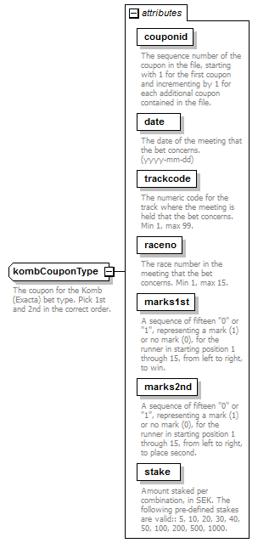
used by
  element | betcouponsType/kombCoupon
attributes
  Name | Type | Use | Default | Fixed | annotation
  couponid | derived by: xs:integer | required
    documentation
    The sequence number of the coupon in the file, starting with 1 for the first coupon and incrementing by 1 for each additional coupon contained in the file.
  date | xs:date | required
    documentation
    The date of the meeting that the bet concerns. (yyyy-mm-dd)
  trackcode | derived by: xs:integer | required
    documentation
    The numeric code for the track where the meeting is held that the bet concerns. Min 1, max 99.
  raceno | derived by: xs:integer | required
    documentation
    The race number in the meeting that the bet concerns. Min 1, max 15.
  marks1st | derived by: xs:string | required
    documentation
    A sequence of fifteen "0" or "1", representing a mark (1) or no mark (0), for the runner in starting position 1 through 15, from left to right, to win.
  marks2nd | derived by: xs:string | required
    documentation
    A sequence of fifteen "0" or "1", representing a mark (1) or no mark (0), for the runner in starting position 1 through 15, from left to right, to place second.
  stake | derived by: xs:integer | required
    documentation
    Amount staked per combination, in SEK. The following pre-defined stakes are valid:: 5, 10, 20, 30, 40, 50, 100, 200, 500, 1000.
annotation
  documentation
  The coupon for the Komb (Exacta) bet type. Pick 1st and 2nd in the correct order.
source | <xs:complexType name="kombCouponType">  <xs:annotation>  <xs:documentation>The coupon for the Komb (Exacta) bet type. Pick 1st and 2nd in the correct order.</xs:documentation>  </xs:annotation>  <xs:attribute name="couponid" use="required">  <xs:annotation>  <xs:documentation>The sequence number of the coupon in the file, starting with 1 for the first coupon and incrementing by 1 for each additional coupon contained in the file.</xs:documentation>  </xs:annotation>  <xs:simpleType>  <xs:restriction base="xs:integer">  <xs:minInclusive value="1"/>  <xs:maxInclusive value="9999"/>  </xs:restriction>  </xs:simpleType>  </xs:attribute>  <xs:attribute name="date" type="xs:date" use="required">  <xs:annotation>  <xs:documentation>The date of the meeting that the bet concerns. (yyyy-mm-dd)</xs:documentation>  </xs:annotation>  </xs:attribute>  <xs:attribute name="trackcode" use="required">  <xs:annotation>  <xs:documentation>The numeric code for the track where the meeting is held that the bet concerns. Min 1, max 99.</xs:documentation>  </xs:annotation>  <xs:simpleType>  <xs:restriction base="xs:integer">  <xs:minInclusive value="1"/>  <xs:maxInclusive value="99"/>  </xs:restriction>  </xs:simpleType>  </xs:attribute>  <xs:attribute name="raceno" use="required">  <xs:annotation>  <xs:documentation>The race number in the meeting that the bet concerns. Min 1, max 15.</xs:documentation>  </xs:annotation>  <xs:simpleType>  <xs:restriction base="xs:integer">  <xs:minInclusive value="1"/>  <xs:maxInclusive value="15"/>  </xs:restriction>  </xs:simpleType>  </xs:attribute>  <xs:attribute name="marks1st" use="required">  <xs:annotation>  <xs:documentation>A sequence of fifteen "0" or "1", representing a mark (1) or no mark (0), for the runner in starting position 1 through 15, from left to right, to win.</xs:documentation>  </xs:annotation>  <xs:simpleType>  <xs:restriction base="xs:string">  <xs:pattern value="[0-1]{15}"/>  </xs:restriction>  </xs:simpleType>  </xs:attribute>  <xs:attribute name="marks2nd" use="required">  <xs:annotation>  <xs:documentation>A sequence of fifteen "0" or "1", representing a mark (1) or no mark (0), for the runner in starting position 1 through 15, from left to right, to place second.</xs:documentation>  </xs:annotation>  <xs:simpleType>  <xs:restriction base="xs:string">  <xs:pattern value="[0-1]{15}"/>  </xs:restriction>  </xs:simpleType>  </xs:attribute>  <xs:attribute name="stake" use="required">  <xs:annotation>  <xs:documentation>Amount staked per combination, in SEK. The following pre-defined stakes are valid:: 5, 10, 20, 30, 40, 50, 100, 200, 500, 1000.</xs:documentation>  </xs:annotation>  <xs:simpleType>  <xs:restriction base="xs:integer">  <xs:minInclusive value="5"/>  <xs:maxInclusive value="1000"/>  </xs:restriction>  </xs:simpleType>  </xs:attribute>  </xs:complexType>

attribute kombCouponType/@couponid
type | restriction of xs:integer
properties
  isRef | 0
  use | required
facets
  Kind | Value | annotation
  minInclusive | 1
  maxInclusive | 9999
annotation
  documentation
  The sequence number of the coupon in the file, starting with 1 for the first coupon and incrementing by 1 for each additional coupon contained in the file.
source | <xs:attribute name="couponid" use="required">  <xs:annotation>  <xs:documentation>The sequence number of the coupon in the file, starting with 1 for the first coupon and incrementing by 1 for each additional coupon contained in the file.</xs:documentation>  </xs:annotation>  <xs:simpleType>  <xs:restriction base="xs:integer">  <xs:minInclusive value="1"/>  <xs:maxInclusive value="9999"/>  </xs:restriction>  </xs:simpleType>  </xs:attribute>

attribute kombCouponType/@date
type | xs:date
properties
  isRef | 0
  use | required
annotation
  documentation
  The date of the meeting that the bet concerns. (yyyy-mm-dd)
source | <xs:attribute name="date" type="xs:date" use="required">  <xs:annotation>  <xs:documentation>The date of the meeting that the bet concerns. (yyyy-mm-dd)</xs:documentation>  </xs:annotation>  </xs:attribute>

attribute kombCouponType/@trackcode
type | restriction of xs:integer
properties
  isRef | 0
  use | required
facets
  Kind | Value | annotation
  minInclusive | 1
  maxInclusive | 99
annotation
  documentation
  The numeric code for the track where the meeting is held that the bet concerns. Min 1, max 99.
source | <xs:attribute name="trackcode" use="required">  <xs:annotation>  <xs:documentation>The numeric code for the track where the meeting is held that the bet concerns. Min 1, max 99.</xs:documentation>  </xs:annotation>  <xs:simpleType>  <xs:restriction base="xs:integer">  <xs:minInclusive value="1"/>  <xs:maxInclusive value="99"/>  </xs:restriction>  </xs:simpleType>  </xs:attribute>

attribute kombCouponType/@raceno
type | restriction of xs:integer
properties
  isRef | 0
  use | required
facets
  Kind | Value | annotation
  minInclusive | 1
  maxInclusive | 15
annotation
  documentation
  The race number in the meeting that the bet concerns. Min 1, max 15.
source | <xs:attribute name="raceno" use="required">  <xs:annotation>  <xs:documentation>The race number in the meeting that the bet concerns. Min 1, max 15.</xs:documentation>  </xs:annotation>  <xs:simpleType>  <xs:restriction base="xs:integer">  <xs:minInclusive value="1"/>  <xs:maxInclusive value="15"/>  </xs:restriction>  </xs:simpleType>  </xs:attribute>

attribute kombCouponType/@marks1st
type | restriction of xs:string
properties
  isRef | 0
  use | required
facets
  Kind | Value | annotation
  pattern | [0-1]{15}
annotation
  documentation
  A sequence of fifteen "0" or "1", representing a mark (1) or no mark (0), for the runner in starting position 1 through 15, from left to right, to win.
source | <xs:attribute name="marks1st" use="required">  <xs:annotation>  <xs:documentation>A sequence of fifteen "0" or "1", representing a mark (1) or no mark (0), for the runner in starting position 1 through 15, from left to right, to win.</xs:documentation>  </xs:annotation>  <xs:simpleType>  <xs:restriction base="xs:string">  <xs:pattern value="[0-1]{15}"/>  </xs:restriction>  </xs:simpleType>  </xs:attribute>

attribute kombCouponType/@marks2nd
type | restriction of xs:string
properties
  isRef | 0
  use | required
facets
  Kind | Value | annotation
  pattern | [0-1]{15}
annotation
  documentation
  A sequence of fifteen "0" or "1", representing a mark (1) or no mark (0), for the runner in starting position 1 through 15, from left to right, to place second.
source | <xs:attribute name="marks2nd" use="required">  <xs:annotation>  <xs:documentation>A sequence of fifteen "0" or "1", representing a mark (1) or no mark (0), for the runner in starting position 1 through 15, from left to right, to place second.</xs:documentation>  </xs:annotation>  <xs:simpleType>  <xs:restriction base="xs:string">  <xs:pattern value="[0-1]{15}"/>  </xs:restriction>  </xs:simpleType>  </xs:attribute>

attribute kombCouponType/@stake
type | restriction of xs:integer
properties
  isRef | 0
  use | required
facets
  Kind | Value | annotation
  minInclusive | 5
  maxInclusive | 1000
annotation
  documentation
  Amount staked per combination, in SEK. The following pre-defined stakes are valid:: 5, 10, 20, 30, 40, 50, 100, 200, 500, 1000.
source | <xs:attribute name="stake" use="required">  <xs:annotation>  <xs:documentation>Amount staked per combination, in SEK. The following pre-defined stakes are valid:: 5, 10, 20, 30, 40, 50, 100, 200, 500, 1000.</xs:documentation>  </xs:annotation>  <xs:simpleType>  <xs:restriction base="xs:integer">  <xs:minInclusive value="5"/>  <xs:maxInclusive value="1000"/>  </xs:restriction>  </xs:simpleType>  </xs:attribute>

complexType LDCouponType
diagram | 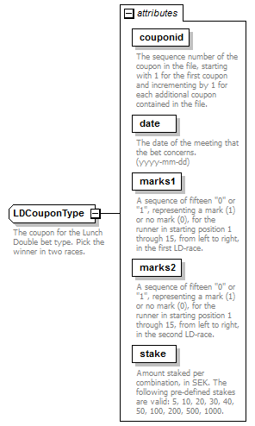
used by
  element | betcouponsType/LDCoupon
attributes
  Name | Type | Use | Default | Fixed | annotation
  couponid | derived by: xs:integer | required
    documentation
    The sequence number of the coupon in the file, starting with 1 for the first coupon and incrementing by 1 for each additional coupon contained in the file.
  date | xs:date | required
    documentation
    The date of the meeting that the bet concerns. (yyyy-mm-dd)
  marks1 | derived by: xs:string | required
    documentation
    A sequence of fifteen "0" or "1", representing a mark (1) or no mark (0), for the runner in starting position 1 through 15, from left to right, in the first LD-race.
  marks2 | derived by: xs:string | required
    documentation
    A sequence of fifteen "0" or "1", representing a mark (1) or no mark (0), for the runner in starting position 1 through 15, from left to right, in the second LD-race.
  stake | derived by: xs:integer | required
    documentation
    Amount staked per combination, in SEK. The following pre-defined stakes are valid: 5, 10, 20, 30, 40, 50, 100, 200, 500, 1000.
annotation
  documentation
  The coupon for the Lunch Double bet type. Pick the winner in two races.
source | <xs:complexType name="LDCouponType">  <xs:annotation>  <xs:documentation>The coupon for the Lunch Double bet type. Pick the winner in two races.</xs:documentation>  </xs:annotation>  <xs:attribute name="couponid" use="required">  <xs:annotation>  <xs:documentation>The sequence number of the coupon in the file, starting with 1 for the first coupon and incrementing by 1 for each additional coupon contained in the file.</xs:documentation>  </xs:annotation>  <xs:simpleType>  <xs:restriction base="xs:integer">  <xs:minInclusive value="1"/>  <xs:maxInclusive value="9999"/>  </xs:restriction>  </xs:simpleType>  </xs:attribute>  <xs:attribute name="date" type="xs:date" use="required">  <xs:annotation>  <xs:documentation>The date of the meeting that the bet concerns. (yyyy-mm-dd)</xs:documentation>  </xs:annotation>  </xs:attribute>  <xs:attribute name="marks1" use="required">  <xs:annotation>  <xs:documentation>A sequence of fifteen "0" or "1", representing a mark (1) or no mark (0), for the runner in starting position 1 through 15, from left to right, in the first LD-race.</xs:documentation>  </xs:annotation>  <xs:simpleType>  <xs:restriction base="xs:string">  <xs:pattern value="[0-1]{15}"/>  </xs:restriction>  </xs:simpleType>  </xs:attribute>  <xs:attribute name="marks2" use="required">  <xs:annotation>  <xs:documentation>A sequence of fifteen "0" or "1", representing a mark (1) or no mark (0), for the runner in starting position 1 through 15, from left to right, in the second LD-race.</xs:documentation>  </xs:annotation>  <xs:simpleType>  <xs:restriction base="xs:string">  <xs:pattern value="[0-1]{15}"/>  </xs:restriction>  </xs:simpleType>  </xs:attribute>  <xs:attribute name="stake" use="required">  <xs:annotation>  <xs:documentation>Amount staked per combination, in SEK. The following pre-defined stakes are valid: 5, 10, 20, 30, 40, 50, 100, 200, 500, 1000.</xs:documentation>  </xs:annotation>  <xs:simpleType>  <xs:restriction base="xs:integer">  <xs:minInclusive value="5"/>  <xs:maxInclusive value="1000"/>  </xs:restriction>  </xs:simpleType>  </xs:attribute>  </xs:complexType>

attribute LDCouponType/@couponid
type | restriction of xs:integer
properties
  isRef | 0
  use | required
facets
  Kind | Value | annotation
  minInclusive | 1
  maxInclusive | 9999
annotation
  documentation
  The sequence number of the coupon in the file, starting with 1 for the first coupon and incrementing by 1 for each additional coupon contained in the file.
source | <xs:attribute name="couponid" use="required">  <xs:annotation>  <xs:documentation>The sequence number of the coupon in the file, starting with 1 for the first coupon and incrementing by 1 for each additional coupon contained in the file.</xs:documentation>  </xs:annotation>  <xs:simpleType>  <xs:restriction base="xs:integer">  <xs:minInclusive value="1"/>  <xs:maxInclusive value="9999"/>  </xs:restriction>  </xs:simpleType>  </xs:attribute>

attribute LDCouponType/@date
type | xs:date
properties
  isRef | 0
  use | required
annotation
  documentation
  The date of the meeting that the bet concerns. (yyyy-mm-dd)
source | <xs:attribute name="date" type="xs:date" use="required">  <xs:annotation>  <xs:documentation>The date of the meeting that the bet concerns. (yyyy-mm-dd)</xs:documentation>  </xs:annotation>  </xs:attribute>

attribute LDCouponType/@marks1
type | restriction of xs:string
properties
  isRef | 0
  use | required
facets
  Kind | Value | annotation
  pattern | [0-1]{15}
annotation
  documentation
  A sequence of fifteen "0" or "1", representing a mark (1) or no mark (0), for the runner in starting position 1 through 15, from left to right, in the first LD-race.
source | <xs:attribute name="marks1" use="required">  <xs:annotation>  <xs:documentation>A sequence of fifteen "0" or "1", representing a mark (1) or no mark (0), for the runner in starting position 1 through 15, from left to right, in the first LD-race.</xs:documentation>  </xs:annotation>  <xs:simpleType>  <xs:restriction base="xs:string">  <xs:pattern value="[0-1]{15}"/>  </xs:restriction>  </xs:simpleType>  </xs:attribute>

attribute LDCouponType/@marks2
type | restriction of xs:string
properties
  isRef | 0
  use | required
facets
  Kind | Value | annotation
  pattern | [0-1]{15}
annotation
  documentation
  A sequence of fifteen "0" or "1", representing a mark (1) or no mark (0), for the runner in starting position 1 through 15, from left to right, in the second LD-race.
source | <xs:attribute name="marks2" use="required">  <xs:annotation>  <xs:documentation>A sequence of fifteen "0" or "1", representing a mark (1) or no mark (0), for the runner in starting position 1 through 15, from left to right, in the second LD-race.</xs:documentation>  </xs:annotation>  <xs:simpleType>  <xs:restriction base="xs:string">  <xs:pattern value="[0-1]{15}"/>  </xs:restriction>  </xs:simpleType>  </xs:attribute>

attribute LDCouponType/@stake
type | restriction of xs:integer
properties
  isRef | 0
  use | required
facets
  Kind | Value | annotation
  minInclusive | 5
  maxInclusive | 1000
annotation
  documentation
  Amount staked per combination, in SEK. The following pre-defined stakes are valid: 5, 10, 20, 30, 40, 50, 100, 200, 500, 1000.
source | <xs:attribute name="stake" use="required">  <xs:annotation>  <xs:documentation>Amount staked per combination, in SEK. The following pre-defined stakes are valid: 5, 10, 20, 30, 40, 50, 100, 200, 500, 1000.</xs:documentation>  </xs:annotation>  <xs:simpleType>  <xs:restriction base="xs:integer">  <xs:minInclusive value="5"/>  <xs:maxInclusive value="1000"/>  </xs:restriction>  </xs:simpleType>  </xs:attribute>

complexType legType
diagram | 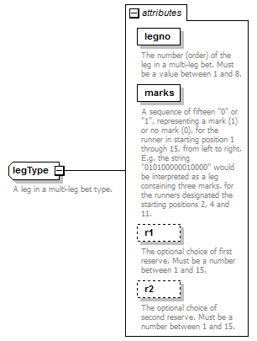
used by
  elements | v5CouponType/leg v64CouponType/leg v65CouponType/leg v75CouponType/leg v86CouponType/leg
attributes
  Name | Type | Use | Default | Fixed | annotation
  legno | derived by: xs:integer | required
    documentation
    The number (order) of the leg in a multi-leg bet. Must be a value between 1 and 8.
  marks | derived by: xs:string | required
    documentation
    A sequence of fifteen "0" or "1", representing a mark (1) or no mark (0), for the runner in starting position 1 through 15, from left to right. E.g. the string "010100000010000" would be interpreted as a leg containing three marks, for the runners designated the starting positions 2, 4 and 11.
  r1 | derived by: xs:integer | optional
    documentation
    The optional choice of first reserve. Must be a number between 1 and 15.
  r2 | derived by: xs:integer | optional
    documentation
    The optional choice of second reserve. Must be a number between 1 and 15.
annotation
  documentation
  A leg in a multi-leg bet type.
source | <xs:complexType name="legType">  <xs:annotation>  <xs:documentation>A leg in a multi-leg bet type.</xs:documentation>  </xs:annotation>  <xs:attribute name="legno" use="required">  <xs:annotation>  <xs:documentation>The number (order) of the leg in a multi-leg bet. Must be a value between 1 and 8.</xs:documentation>  </xs:annotation>  <xs:simpleType>  <xs:restriction base="xs:integer">  <xs:minInclusive value="1"/>  <xs:maxInclusive value="8"/>  </xs:restriction>  </xs:simpleType>  </xs:attribute>  <xs:attribute name="marks" use="required">  <xs:annotation>  <xs:documentation>A sequence of fifteen "0" or "1", representing a mark (1) or no mark (0), for the runner in starting position 1 through 15, from left to right. E.g. the string "010100000010000" would be interpreted as a leg containing three marks, for the runners designated the starting positions 2, 4 and 11.</xs:documentation>  </xs:annotation>  <xs:simpleType>  <xs:restriction base="xs:string">  <xs:pattern value="[0-1]{15}"/>  </xs:restriction>  </xs:simpleType>  </xs:attribute>  <xs:attribute name="r1" use="optional">  <xs:annotation>  <xs:documentation>The optional choice of first reserve. Must be a number between 1 and 15. </xs:documentation>  </xs:annotation>  <xs:simpleType>  <xs:restriction base="xs:integer">  <xs:minInclusive value="1"/>  <xs:maxInclusive value="15"/>  </xs:restriction>  </xs:simpleType>  </xs:attribute>  <xs:attribute name="r2" use="optional">  <xs:annotation>  <xs:documentation>The optional choice of second reserve. Must be a number between 1 and 15. </xs:documentation>  </xs:annotation>  <xs:simpleType>  <xs:restriction base="xs:integer">  <xs:minInclusive value="1"/>  <xs:maxInclusive value="15"/>  </xs:restriction>  </xs:simpleType>  </xs:attribute>  </xs:complexType>

attribute legType/@legno
type | restriction of xs:integer
properties
  isRef | 0
  use | required
facets
  Kind | Value | annotation
  minInclusive | 1
  maxInclusive | 8
annotation
  documentation
  The number (order) of the leg in a multi-leg bet. Must be a value between 1 and 8.
source | <xs:attribute name="legno" use="required">  <xs:annotation>  <xs:documentation>The number (order) of the leg in a multi-leg bet. Must be a value between 1 and 8.</xs:documentation>  </xs:annotation>  <xs:simpleType>  <xs:restriction base="xs:integer">  <xs:minInclusive value="1"/>  <xs:maxInclusive value="8"/>  </xs:restriction>  </xs:simpleType>  </xs:attribute>

attribute legType/@marks
type | restriction of xs:string
properties
  isRef | 0
  use | required
facets
  Kind | Value | annotation
  pattern | [0-1]{15}
annotation
  documentation
  A sequence of fifteen "0" or "1", representing a mark (1) or no mark (0), for the runner in starting position 1 through 15, from left to right. E.g. the string "010100000010000" would be interpreted as a leg containing three marks, for the runners designated the starting positions 2, 4 and 11.
source | <xs:attribute name="marks" use="required">  <xs:annotation>  <xs:documentation>A sequence of fifteen "0" or "1", representing a mark (1) or no mark (0), for the runner in starting position 1 through 15, from left to right. E.g. the string "010100000010000" would be interpreted as a leg containing three marks, for the runners designated the starting positions 2, 4 and 11.</xs:documentation>  </xs:annotation>  <xs:simpleType>  <xs:restriction base="xs:string">  <xs:pattern value="[0-1]{15}"/>  </xs:restriction>  </xs:simpleType>  </xs:attribute>

attribute legType/@r1
type | restriction of xs:integer
properties
  isRef | 0
  use | optional
facets
  Kind | Value | annotation
  minInclusive | 1
  maxInclusive | 15
annotation
  documentation
  The optional choice of first reserve. Must be a number between 1 and 15.
source | <xs:attribute name="r1" use="optional">  <xs:annotation>  <xs:documentation>The optional choice of first reserve. Must be a number between 1 and 15. </xs:documentation>  </xs:annotation>  <xs:simpleType>  <xs:restriction base="xs:integer">  <xs:minInclusive value="1"/>  <xs:maxInclusive value="15"/>  </xs:restriction>  </xs:simpleType>  </xs:attribute>

attribute legType/@r2
type | restriction of xs:integer
properties
  isRef | 0
  use | optional
facets
  Kind | Value | annotation
  minInclusive | 1
  maxInclusive | 15
annotation
  documentation
  The optional choice of second reserve. Must be a number between 1 and 15.
source | <xs:attribute name="r2" use="optional">  <xs:annotation>  <xs:documentation>The optional choice of second reserve. Must be a number between 1 and 15. </xs:documentation>  </xs:annotation>  <xs:simpleType>  <xs:restriction base="xs:integer">  <xs:minInclusive value="1"/>  <xs:maxInclusive value="15"/>  </xs:restriction>  </xs:simpleType>  </xs:attribute>

complexType legType20
diagram | 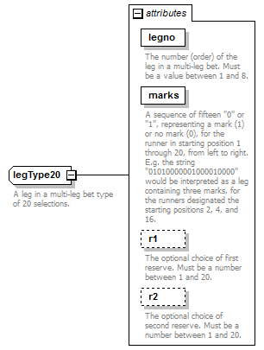
used by
  element | v4CouponType/leg
attributes
  Name | Type | Use | Default | Fixed | annotation
  legno | derived by: xs:integer | required
    documentation
    The number (order) of the leg in a multi-leg bet. Must be a value between 1 and 8.
  marks | derived by: xs:string | required
    documentation
    A sequence of fifteen "0" or "1", representing a mark (1) or no mark (0), for the runner in starting position 1 through 20, from left to right. E.g. the string "01010000001000010000" would be interpreted as a leg containing three marks, for the runners designated the starting positions 2, 4, and 16.
  r1 | derived by: xs:integer | optional
    documentation
    The optional choice of first reserve. Must be a number between 1 and 20.
  r2 | derived by: xs:integer | optional
    documentation
    The optional choice of second reserve. Must be a number between 1 and 20.
annotation
  documentation
  A leg in a multi-leg bet type of 20 selections.
source | <xs:complexType name="legType20">  <xs:annotation>  <xs:documentation>A leg in a multi-leg bet type of 20 selections.</xs:documentation>  </xs:annotation>  <xs:attribute name="legno" use="required">  <xs:annotation>  <xs:documentation>The number (order) of the leg in a multi-leg bet. Must be a value between 1 and 8.</xs:documentation>  </xs:annotation>  <xs:simpleType>  <xs:restriction base="xs:integer">  <xs:minInclusive value="1"/>  <xs:maxInclusive value="8"/>  </xs:restriction>  </xs:simpleType>  </xs:attribute>  <xs:attribute name="marks" use="required">  <xs:annotation>  <xs:documentation>A sequence of fifteen "0" or "1", representing a mark (1) or no mark (0), for the runner in starting position 1 through 20, from left to right. E.g. the string "01010000001000010000" would be interpreted as a leg containing three marks, for the runners designated the starting positions 2, 4, and 16.</xs:documentation>  </xs:annotation>  <xs:simpleType>  <xs:restriction base="xs:string">  <xs:pattern value="[0-1]{20}"/>  </xs:restriction>  </xs:simpleType>  </xs:attribute>  <xs:attribute name="r1" use="optional">  <xs:annotation>  <xs:documentation>The optional choice of first reserve. Must be a number between 1 and 20. </xs:documentation>  </xs:annotation>  <xs:simpleType>  <xs:restriction base="xs:integer">  <xs:minInclusive value="1"/>  <xs:maxInclusive value="20"/>  </xs:restriction>  </xs:simpleType>  </xs:attribute>  <xs:attribute name="r2" use="optional">  <xs:annotation>  <xs:documentation>The optional choice of second reserve. Must be a number between 1 and 20. </xs:documentation>  </xs:annotation>  <xs:simpleType>  <xs:restriction base="xs:integer">  <xs:minInclusive value="1"/>  <xs:maxInclusive value="20"/>  </xs:restriction>  </xs:simpleType>  </xs:attribute>  </xs:complexType>

attribute legType20/@legno
type | restriction of xs:integer
properties
  isRef | 0
  use | required
facets
  Kind | Value | annotation
  minInclusive | 1
  maxInclusive | 8
annotation
  documentation
  The number (order) of the leg in a multi-leg bet. Must be a value between 1 and 8.
source | <xs:attribute name="legno" use="required">  <xs:annotation>  <xs:documentation>The number (order) of the leg in a multi-leg bet. Must be a value between 1 and 8.</xs:documentation>  </xs:annotation>  <xs:simpleType>  <xs:restriction base="xs:integer">  <xs:minInclusive value="1"/>  <xs:maxInclusive value="8"/>  </xs:restriction>  </xs:simpleType>  </xs:attribute>

attribute legType20/@marks
type | restriction of xs:string
properties
  isRef | 0
  use | required
facets
  Kind | Value | annotation
  pattern | [0-1]{20}
annotation
  documentation
  A sequence of fifteen "0" or "1", representing a mark (1) or no mark (0), for the runner in starting position 1 through 20, from left to right. E.g. the string "01010000001000010000" would be interpreted as a leg containing three marks, for the runners designated the starting positions 2, 4, and 16.
source | <xs:attribute name="marks" use="required">  <xs:annotation>  <xs:documentation>A sequence of fifteen "0" or "1", representing a mark (1) or no mark (0), for the runner in starting position 1 through 20, from left to right. E.g. the string "01010000001000010000" would be interpreted as a leg containing three marks, for the runners designated the starting positions 2, 4, and 16.</xs:documentation>  </xs:annotation>  <xs:simpleType>  <xs:restriction base="xs:string">  <xs:pattern value="[0-1]{20}"/>  </xs:restriction>  </xs:simpleType>  </xs:attribute>

attribute legType20/@r1
type | restriction of xs:integer
properties
  isRef | 0
  use | optional
facets
  Kind | Value | annotation
  minInclusive | 1
  maxInclusive | 20
annotation
  documentation
  The optional choice of first reserve. Must be a number between 1 and 20.
source | <xs:attribute name="r1" use="optional">  <xs:annotation>  <xs:documentation>The optional choice of first reserve. Must be a number between 1 and 20. </xs:documentation>  </xs:annotation>  <xs:simpleType>  <xs:restriction base="xs:integer">  <xs:minInclusive value="1"/>  <xs:maxInclusive value="20"/>  </xs:restriction>  </xs:simpleType>  </xs:attribute>

attribute legType20/@r2
type | restriction of xs:integer
properties
  isRef | 0
  use | optional
facets
  Kind | Value | annotation
  minInclusive | 1
  maxInclusive | 20
annotation
  documentation
  The optional choice of second reserve. Must be a number between 1 and 20.
source | <xs:attribute name="r2" use="optional">  <xs:annotation>  <xs:documentation>The optional choice of second reserve. Must be a number between 1 and 20. </xs:documentation>  </xs:annotation>  <xs:simpleType>  <xs:restriction base="xs:integer">  <xs:minInclusive value="1"/>  <xs:maxInclusive value="20"/>  </xs:restriction>  </xs:simpleType>  </xs:attribute>

complexType raketCouponType
diagram | 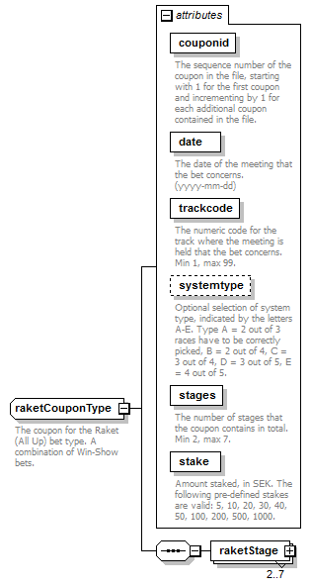
children | raketStage
used by
  element | betcouponsType/raketCoupon
attributes
  Name | Type | Use | Default | Fixed | annotation
  couponid | derived by: xs:integer | required
    documentation
    The sequence number of the coupon in the file, starting with 1 for the first coupon and incrementing by 1 for each additional coupon contained in the file.
  date | xs:date | required
    documentation
    The date of the meeting that the bet concerns. (yyyy-mm-dd)
  trackcode | derived by: xs:integer | required
    documentation
    The numeric code for the track where the meeting is held that the bet concerns. Min 1, max 99.
  systemtype | derived by: xs:string | optional
    documentation
    Optional selection of system type, indicated by the letters A-E. Type A = 2 out of 3 races have to be correctly picked, B = 2 out of 4, C = 3 out of 4, D = 3 out of 5, E = 4 out of 5.
  stages | derived by: xs:integer | required
    documentation
    The number of stages that the coupon contains in total. Min 2, max 7.
  stake | derived by: xs:integer | required
    documentation
    Amount staked, in SEK. The following pre-defined stakes are valid: 5, 10, 20, 30, 40, 50, 100, 200, 500, 1000.
annotation
  documentation
  The coupon for the Raket (All Up) bet type. A combination of Win-Show bets.
source | <xs:complexType name="raketCouponType">  <xs:annotation>  <xs:documentation>The coupon for the Raket (All Up) bet type. A combination of Win-Show bets.</xs:documentation>  </xs:annotation>  <xs:sequence>  <xs:element name="raketStage" type="raketStageType" minOccurs="2" maxOccurs="7"/>  </xs:sequence>  <xs:attribute name="couponid" use="required">  <xs:annotation>  <xs:documentation>The sequence number of the coupon in the file, starting with 1 for the first coupon and incrementing by 1 for each additional coupon contained in the file.</xs:documentation>  </xs:annotation>  <xs:simpleType>  <xs:restriction base="xs:integer">  <xs:minInclusive value="1"/>  <xs:maxInclusive value="9999"/>  </xs:restriction>  </xs:simpleType>  </xs:attribute>  <xs:attribute name="date" type="xs:date" use="required">  <xs:annotation>  <xs:documentation>The date of the meeting that the bet concerns. (yyyy-mm-dd)</xs:documentation>  </xs:annotation>  </xs:attribute>  <xs:attribute name="trackcode" use="required">  <xs:annotation>  <xs:documentation>The numeric code for the track where the meeting is held that the bet concerns. Min 1, max 99.</xs:documentation>  </xs:annotation>  <xs:simpleType>  <xs:restriction base="xs:integer">  <xs:minInclusive value="1"/>  <xs:maxInclusive value="99"/>  </xs:restriction>  </xs:simpleType>  </xs:attribute>  <xs:attribute name="systemtype" use="optional">  <xs:annotation>  <xs:documentation>Optional selection of system type, indicated by the letters A-E. Type A = 2 out of 3 races have to be correctly picked, B = 2 out of 4, C = 3 out of 4, D = 3 out of 5, E = 4 out of 5.</xs:documentation>  </xs:annotation>  <xs:simpleType>  <xs:restriction base="xs:string">  <xs:pattern value="[A-E]{1}"/>  </xs:restriction>  </xs:simpleType>  </xs:attribute>  <xs:attribute name="stages" use="required">  <xs:annotation>  <xs:documentation>The number of stages that the coupon contains in total. Min 2, max 7.</xs:documentation>  </xs:annotation>  <xs:simpleType>  <xs:restriction base="xs:integer">  <xs:minInclusive value="2"/>  <xs:maxInclusive value="7"/>  </xs:restriction>  </xs:simpleType>  </xs:attribute>  <xs:attribute name="stake" use="required">  <xs:annotation>  <xs:documentation>Amount staked, in SEK. The following pre-defined stakes are valid: 5, 10, 20, 30, 40, 50, 100, 200, 500, 1000.</xs:documentation>  </xs:annotation>  <xs:simpleType>  <xs:restriction base="xs:integer">  <xs:minInclusive value="5"/>  <xs:maxInclusive value="1000"/>  </xs:restriction>  </xs:simpleType>  </xs:attribute>  </xs:complexType>

attribute raketCouponType/@couponid
type | restriction of xs:integer
properties
  isRef | 0
  use | required
facets
  Kind | Value | annotation
  minInclusive | 1
  maxInclusive | 9999
annotation
  documentation
  The sequence number of the coupon in the file, starting with 1 for the first coupon and incrementing by 1 for each additional coupon contained in the file.
source | <xs:attribute name="couponid" use="required">  <xs:annotation>  <xs:documentation>The sequence number of the coupon in the file, starting with 1 for the first coupon and incrementing by 1 for each additional coupon contained in the file.</xs:documentation>  </xs:annotation>  <xs:simpleType>  <xs:restriction base="xs:integer">  <xs:minInclusive value="1"/>  <xs:maxInclusive value="9999"/>  </xs:restriction>  </xs:simpleType>  </xs:attribute>

attribute raketCouponType/@date
type | xs:date
properties
  isRef | 0
  use | required
annotation
  documentation
  The date of the meeting that the bet concerns. (yyyy-mm-dd)
source | <xs:attribute name="date" type="xs:date" use="required">  <xs:annotation>  <xs:documentation>The date of the meeting that the bet concerns. (yyyy-mm-dd)</xs:documentation>  </xs:annotation>  </xs:attribute>

attribute raketCouponType/@trackcode
type | restriction of xs:integer
properties
  isRef | 0
  use | required
facets
  Kind | Value | annotation
  minInclusive | 1
  maxInclusive | 99
annotation
  documentation
  The numeric code for the track where the meeting is held that the bet concerns. Min 1, max 99.
source | <xs:attribute name="trackcode" use="required">  <xs:annotation>  <xs:documentation>The numeric code for the track where the meeting is held that the bet concerns. Min 1, max 99.</xs:documentation>  </xs:annotation>  <xs:simpleType>  <xs:restriction base="xs:integer">  <xs:minInclusive value="1"/>  <xs:maxInclusive value="99"/>  </xs:restriction>  </xs:simpleType>  </xs:attribute>

attribute raketCouponType/@systemtype
type | restriction of xs:string
properties
  isRef | 0
  use | optional
facets
  Kind | Value | annotation
  pattern | [A-E]{1}
annotation
  documentation
  Optional selection of system type, indicated by the letters A-E. Type A = 2 out of 3 races have to be correctly picked, B = 2 out of 4, C = 3 out of 4, D = 3 out of 5, E = 4 out of 5.
source | <xs:attribute name="systemtype" use="optional">  <xs:annotation>  <xs:documentation>Optional selection of system type, indicated by the letters A-E. Type A = 2 out of 3 races have to be correctly picked, B = 2 out of 4, C = 3 out of 4, D = 3 out of 5, E = 4 out of 5.</xs:documentation>  </xs:annotation>  <xs:simpleType>  <xs:restriction base="xs:string">  <xs:pattern value="[A-E]{1}"/>  </xs:restriction>  </xs:simpleType>  </xs:attribute>

attribute raketCouponType/@stages
type | restriction of xs:integer
properties
  isRef | 0
  use | required
facets
  Kind | Value | annotation
  minInclusive | 2
  maxInclusive | 7
annotation
  documentation
  The number of stages that the coupon contains in total. Min 2, max 7.
source | <xs:attribute name="stages" use="required">  <xs:annotation>  <xs:documentation>The number of stages that the coupon contains in total. Min 2, max 7.</xs:documentation>  </xs:annotation>  <xs:simpleType>  <xs:restriction base="xs:integer">  <xs:minInclusive value="2"/>  <xs:maxInclusive value="7"/>  </xs:restriction>  </xs:simpleType>  </xs:attribute>

attribute raketCouponType/@stake
type | restriction of xs:integer
properties
  isRef | 0
  use | required
facets
  Kind | Value | annotation
  minInclusive | 5
  maxInclusive | 1000
annotation
  documentation
  Amount staked, in SEK. The following pre-defined stakes are valid: 5, 10, 20, 30, 40, 50, 100, 200, 500, 1000.
source | <xs:attribute name="stake" use="required">  <xs:annotation>  <xs:documentation>Amount staked, in SEK. The following pre-defined stakes are valid: 5, 10, 20, 30, 40, 50, 100, 200, 500, 1000.</xs:documentation>  </xs:annotation>  <xs:simpleType>  <xs:restriction base="xs:integer">  <xs:minInclusive value="5"/>  <xs:maxInclusive value="1000"/>  </xs:restriction>  </xs:simpleType>  </xs:attribute>

element raketCouponType/raketStage
diagram | 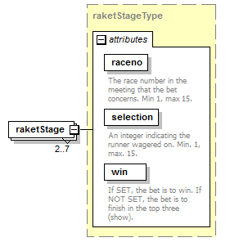
type | raketStageType
properties
  isRef | 0
  minOcc | 2
  maxOcc | 7
  content | complex
attributes
  Name | Type | Use | Default | Fixed | annotation
  raceno | derived by: xs:integer | required
    documentation
    The race number in the meeting that the bet concerns. Min 1, max 15.
  selection | derived by: xs:integer | required
    documentation
    An integer indicating the runner wagered on. Min. 1, max. 15.
  win | xs:boolean | required
    documentation
    If SET, the bet is to win. If NOT SET, the bet is to finish in the top three (show).
source | <xs:element name="raketStage" type="raketStageType" minOccurs="2" maxOccurs="7"/>

complexType raketStageType
diagram | 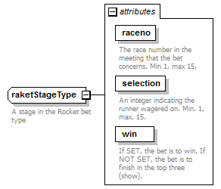
used by
  element | raketCouponType/raketStage
attributes
  Name | Type | Use | Default | Fixed | annotation
  raceno | derived by: xs:integer | required
    documentation
    The race number in the meeting that the bet concerns. Min 1, max 15.
  selection | derived by: xs:integer | required
    documentation
    An integer indicating the runner wagered on. Min. 1, max. 15.
  win | xs:boolean | required
    documentation
    If SET, the bet is to win. If NOT SET, the bet is to finish in the top three (show).
annotation
  documentation
  A stage in the Rocket bet type
source | <xs:complexType name="raketStageType">  <xs:annotation>  <xs:documentation>A stage in the Rocket bet type</xs:documentation>  </xs:annotation>  <xs:attribute name="raceno" use="required">  <xs:annotation>  <xs:documentation>The race number in the meeting that the bet concerns. Min 1, max 15.</xs:documentation>  </xs:annotation>  <xs:simpleType>  <xs:restriction base="xs:integer">  <xs:minInclusive value="1"/>  <xs:maxInclusive value="15"/>  </xs:restriction>  </xs:simpleType>  </xs:attribute>  <xs:attribute name="selection" use="required">  <xs:annotation>  <xs:documentation>An integer indicating the runner wagered on. Min. 1, max. 15.</xs:documentation>  </xs:annotation>  <xs:simpleType>  <xs:restriction base="xs:integer">  <xs:minInclusive value="1"/>  <xs:maxInclusive value="15"/>  </xs:restriction>  </xs:simpleType>  </xs:attribute>  <xs:attribute name="win" type="xs:boolean" use="required">  <xs:annotation>  <xs:documentation>If SET, the bet is to win. If NOT SET, the bet is to finish in the top three (show).</xs:documentation>  </xs:annotation>  </xs:attribute>  </xs:complexType>

attribute raketStageType/@raceno
type | restriction of xs:integer
properties
  isRef | 0
  use | required
facets
  Kind | Value | annotation
  minInclusive | 1
  maxInclusive | 15
annotation
  documentation
  The race number in the meeting that the bet concerns. Min 1, max 15.
source | <xs:attribute name="raceno" use="required">  <xs:annotation>  <xs:documentation>The race number in the meeting that the bet concerns. Min 1, max 15.</xs:documentation>  </xs:annotation>  <xs:simpleType>  <xs:restriction base="xs:integer">  <xs:minInclusive value="1"/>  <xs:maxInclusive value="15"/>  </xs:restriction>  </xs:simpleType>  </xs:attribute>

attribute raketStageType/@selection
type | restriction of xs:integer
properties
  isRef | 0
  use | required
facets
  Kind | Value | annotation
  minInclusive | 1
  maxInclusive | 15
annotation
  documentation
  An integer indicating the runner wagered on. Min. 1, max. 15.
source | <xs:attribute name="selection" use="required">  <xs:annotation>  <xs:documentation>An integer indicating the runner wagered on. Min. 1, max. 15.</xs:documentation>  </xs:annotation>  <xs:simpleType>  <xs:restriction base="xs:integer">  <xs:minInclusive value="1"/>  <xs:maxInclusive value="15"/>  </xs:restriction>  </xs:simpleType>  </xs:attribute>

attribute raketStageType/@win
type | xs:boolean
properties
  isRef | 0
  use | required
annotation
  documentation
  If SET, the bet is to win. If NOT SET, the bet is to finish in the top three (show).
source | <xs:attribute name="win" type="xs:boolean" use="required">  <xs:annotation>  <xs:documentation>If SET, the bet is to win. If NOT SET, the bet is to finish in the top three (show).</xs:documentation>  </xs:annotation>  </xs:attribute>

complexType trioCouponType
diagram | 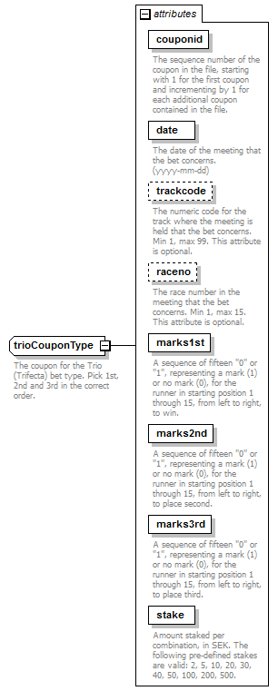
used by
  element | betcouponsType/trioCoupon
attributes
  Name | Type | Use | Default | Fixed | annotation
  couponid | derived by: xs:integer | required
    documentation
    The sequence number of the coupon in the file, starting with 1 for the first coupon and incrementing by 1 for each additional coupon contained in the file.
  date | xs:date | required
    documentation
    The date of the meeting that the bet concerns. (yyyy-mm-dd)
  trackcode | derived by: xs:integer | optional
    documentation
    The numeric code for the track where the meeting is held that the bet concerns. Min 1, max 99. This attribute is optional.
  raceno | derived by: xs:integer | optional
    documentation
    The race number in the meeting that the bet concerns. Min 1, max 15. This attribute is optional.
  marks1st | derived by: xs:string | required
    documentation
    A sequence of fifteen "0" or "1", representing a mark (1) or no mark (0), for the runner in starting position 1 through 15, from left to right, to win.
  marks2nd | derived by: xs:string | required
    documentation
    A sequence of fifteen "0" or "1", representing a mark (1) or no mark (0), for the runner in starting position 1 through 15, from left to right, to place second.
  marks3rd | derived by: xs:string | required
    documentation
    A sequence of fifteen "0" or "1", representing a mark (1) or no mark (0), for the runner in starting position 1 through 15, from left to right, to place third.
  stake | derived by: xs:integer | required
    documentation
    Amount staked per combination, in SEK. The following pre-defined stakes are valid: 2, 5, 10, 20, 30, 40, 50, 100, 200, 500.
annotation
  documentation
  The coupon for the Trio (Trifecta) bet type. Pick 1st, 2nd and 3rd in the correct order.
source | <xs:complexType name="trioCouponType">  <xs:annotation>  <xs:documentation>The coupon for the Trio (Trifecta) bet type. Pick 1st, 2nd and 3rd in the correct order.</xs:documentation>  </xs:annotation>  <xs:attribute name="couponid" use="required">  <xs:annotation>  <xs:documentation>The sequence number of the coupon in the file, starting with 1 for the first coupon and incrementing by 1 for each additional coupon contained in the file.</xs:documentation>  </xs:annotation>  <xs:simpleType>  <xs:restriction base="xs:integer">  <xs:minInclusive value="1"/>  <xs:maxInclusive value="9999"/>  </xs:restriction>  </xs:simpleType>  </xs:attribute>  <xs:attribute name="date" type="xs:date" use="required">  <xs:annotation>  <xs:documentation>The date of the meeting that the bet concerns. (yyyy-mm-dd)</xs:documentation>  </xs:annotation>  </xs:attribute>  <xs:attribute name="trackcode" use="optional">  <xs:annotation>  <xs:documentation>The numeric code for the track where the meeting is held that the bet concerns. Min 1, max 99. This attribute is optional.</xs:documentation>  </xs:annotation>  <xs:simpleType>  <xs:restriction base="xs:integer">  <xs:minInclusive value="1"/>  <xs:maxInclusive value="99"/>  </xs:restriction>  </xs:simpleType>  </xs:attribute>  <xs:attribute name="raceno" use="optional">  <xs:annotation>  <xs:documentation>The race number in the meeting that the bet concerns. Min 1, max 15. This attribute is optional.</xs:documentation>  </xs:annotation>  <xs:simpleType>  <xs:restriction base="xs:integer">  <xs:minInclusive value="1"/>  <xs:maxInclusive value="15"/>  </xs:restriction>  </xs:simpleType>  </xs:attribute>  <xs:attribute name="marks1st" use="required">  <xs:annotation>  <xs:documentation>A sequence of fifteen "0" or "1", representing a mark (1) or no mark (0), for the runner in starting position 1 through 15, from left to right, to win.</xs:documentation>  </xs:annotation>  <xs:simpleType>  <xs:restriction base="xs:string">  <xs:pattern value="[0-1]{15}"/>  </xs:restriction>  </xs:simpleType>  </xs:attribute>  <xs:attribute name="marks2nd" use="required">  <xs:annotation>  <xs:documentation>A sequence of fifteen "0" or "1", representing a mark (1) or no mark (0), for the runner in starting position 1 through 15, from left to right, to place second.</xs:documentation>  </xs:annotation>  <xs:simpleType>  <xs:restriction base="xs:string">  <xs:pattern value="[0-1]{15}"/>  </xs:restriction>  </xs:simpleType>  </xs:attribute>  <xs:attribute name="marks3rd" use="required">  <xs:annotation>  <xs:documentation>A sequence of fifteen "0" or "1", representing a mark (1) or no mark (0), for the runner in starting position 1 through 15, from left to right, to place third.</xs:documentation>  </xs:annotation>  <xs:simpleType>  <xs:restriction base="xs:string">  <xs:pattern value="[0-1]{15}"/>  </xs:restriction>  </xs:simpleType>  </xs:attribute>  <xs:attribute name="stake" use="required">  <xs:annotation>  <xs:documentation>Amount staked per combination, in SEK. The following pre-defined stakes are valid: 2, 5, 10, 20, 30, 40, 50, 100, 200, 500.</xs:documentation>  </xs:annotation>  <xs:simpleType>  <xs:restriction base="xs:integer">  <xs:minInclusive value="2"/>  <xs:maxInclusive value="500"/>  </xs:restriction>  </xs:simpleType>  </xs:attribute>  </xs:complexType>

attribute trioCouponType/@couponid
type | restriction of xs:integer
properties
  isRef | 0
  use | required
facets
  Kind | Value | annotation
  minInclusive | 1
  maxInclusive | 9999
annotation
  documentation
  The sequence number of the coupon in the file, starting with 1 for the first coupon and incrementing by 1 for each additional coupon contained in the file.
source | <xs:attribute name="couponid" use="required">  <xs:annotation>  <xs:documentation>The sequence number of the coupon in the file, starting with 1 for the first coupon and incrementing by 1 for each additional coupon contained in the file.</xs:documentation>  </xs:annotation>  <xs:simpleType>  <xs:restriction base="xs:integer">  <xs:minInclusive value="1"/>  <xs:maxInclusive value="9999"/>  </xs:restriction>  </xs:simpleType>  </xs:attribute>

attribute trioCouponType/@date
type | xs:date
properties
  isRef | 0
  use | required
annotation
  documentation
  The date of the meeting that the bet concerns. (yyyy-mm-dd)
source | <xs:attribute name="date" type="xs:date" use="required">  <xs:annotation>  <xs:documentation>The date of the meeting that the bet concerns. (yyyy-mm-dd)</xs:documentation>  </xs:annotation>  </xs:attribute>

attribute trioCouponType/@trackcode
type | restriction of xs:integer
properties
  isRef | 0
  use | optional
facets
  Kind | Value | annotation
  minInclusive | 1
  maxInclusive | 99
annotation
  documentation
  The numeric code for the track where the meeting is held that the bet concerns. Min 1, max 99. This attribute is optional.
source | <xs:attribute name="trackcode" use="optional">  <xs:annotation>  <xs:documentation>The numeric code for the track where the meeting is held that the bet concerns. Min 1, max 99. This attribute is optional.</xs:documentation>  </xs:annotation>  <xs:simpleType>  <xs:restriction base="xs:integer">  <xs:minInclusive value="1"/>  <xs:maxInclusive value="99"/>  </xs:restriction>  </xs:simpleType>  </xs:attribute>

attribute trioCouponType/@raceno
type | restriction of xs:integer
properties
  isRef | 0
  use | optional
facets
  Kind | Value | annotation
  minInclusive | 1
  maxInclusive | 15
annotation
  documentation
  The race number in the meeting that the bet concerns. Min 1, max 15. This attribute is optional.
source | <xs:attribute name="raceno" use="optional">  <xs:annotation>  <xs:documentation>The race number in the meeting that the bet concerns. Min 1, max 15. This attribute is optional.</xs:documentation>  </xs:annotation>  <xs:simpleType>  <xs:restriction base="xs:integer">  <xs:minInclusive value="1"/>  <xs:maxInclusive value="15"/>  </xs:restriction>  </xs:simpleType>  </xs:attribute>

attribute trioCouponType/@marks1st
type | restriction of xs:string
properties
  isRef | 0
  use | required
facets
  Kind | Value | annotation
  pattern | [0-1]{15}
annotation
  documentation
  A sequence of fifteen "0" or "1", representing a mark (1) or no mark (0), for the runner in starting position 1 through 15, from left to right, to win.
source | <xs:attribute name="marks1st" use="required">  <xs:annotation>  <xs:documentation>A sequence of fifteen "0" or "1", representing a mark (1) or no mark (0), for the runner in starting position 1 through 15, from left to right, to win.</xs:documentation>  </xs:annotation>  <xs:simpleType>  <xs:restriction base="xs:string">  <xs:pattern value="[0-1]{15}"/>  </xs:restriction>  </xs:simpleType>  </xs:attribute>

attribute trioCouponType/@marks2nd
type | restriction of xs:string
properties
  isRef | 0
  use | required
facets
  Kind | Value | annotation
  pattern | [0-1]{15}
annotation
  documentation
  A sequence of fifteen "0" or "1", representing a mark (1) or no mark (0), for the runner in starting position 1 through 15, from left to right, to place second.
source | <xs:attribute name="marks2nd" use="required">  <xs:annotation>  <xs:documentation>A sequence of fifteen "0" or "1", representing a mark (1) or no mark (0), for the runner in starting position 1 through 15, from left to right, to place second.</xs:documentation>  </xs:annotation>  <xs:simpleType>  <xs:restriction base="xs:string">  <xs:pattern value="[0-1]{15}"/>  </xs:restriction>  </xs:simpleType>  </xs:attribute>

attribute trioCouponType/@marks3rd
type | restriction of xs:string
properties
  isRef | 0
  use | required
facets
  Kind | Value | annotation
  pattern | [0-1]{15}
annotation
  documentation
  A sequence of fifteen "0" or "1", representing a mark (1) or no mark (0), for the runner in starting position 1 through 15, from left to right, to place third.
source | <xs:attribute name="marks3rd" use="required">  <xs:annotation>  <xs:documentation>A sequence of fifteen "0" or "1", representing a mark (1) or no mark (0), for the runner in starting position 1 through 15, from left to right, to place third.</xs:documentation>  </xs:annotation>  <xs:simpleType>  <xs:restriction base="xs:string">  <xs:pattern value="[0-1]{15}"/>  </xs:restriction>  </xs:simpleType>  </xs:attribute>

attribute trioCouponType/@stake
type | restriction of xs:integer
properties
  isRef | 0
  use | required
facets
  Kind | Value | annotation
  minInclusive | 2
  maxInclusive | 500
annotation
  documentation
  Amount staked per combination, in SEK. The following pre-defined stakes are valid: 2, 5, 10, 20, 30, 40, 50, 100, 200, 500.
source | <xs:attribute name="stake" use="required">  <xs:annotation>  <xs:documentation>Amount staked per combination, in SEK. The following pre-defined stakes are valid: 2, 5, 10, 20, 30, 40, 50, 100, 200, 500.</xs:documentation>  </xs:annotation>  <xs:simpleType>  <xs:restriction base="xs:integer">  <xs:minInclusive value="2"/>  <xs:maxInclusive value="500"/>  </xs:restriction>  </xs:simpleType>  </xs:attribute>

complexType tvillingCouponType
diagram | 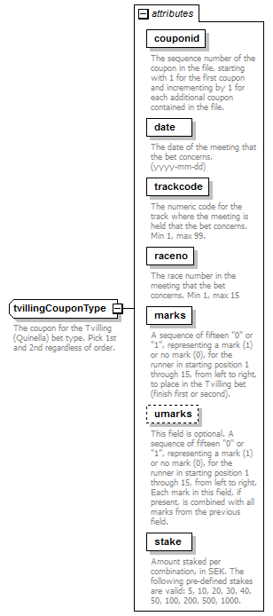
used by
  element | betcouponsType/tvillingCoupon
attributes
  Name | Type | Use | Default | Fixed | annotation
  couponid | derived by: xs:integer | required
    documentation
    The sequence number of the coupon in the file, starting with 1 for the first coupon and incrementing by 1 for each additional coupon contained in the file.
  date | xs:date | required
    documentation
    The date of the meeting that the bet concerns. (yyyy-mm-dd)
  trackcode | derived by: xs:integer | required
    documentation
    The numeric code for the track where the meeting is held that the bet concerns. Min 1, max 99.
  raceno | derived by: xs:integer | required
    documentation
    The race number in the meeting that the bet concerns. Min 1, max 15
  marks | derived by: xs:string | required
    documentation
    A sequence of fifteen "0" or "1", representing a mark (1) or no mark (0), for the runner in starting position 1 through 15, from left to right, to place in the Tvilling bet (finish first or second).
  umarks | derived by: xs:string | optional
    documentation
    This field is optional. A sequence of fifteen "0" or "1", representing a mark (1) or no mark (0), for the runner in starting position 1 through 15, from left to right. Each mark in this field, if present, is combined with all marks from the previous field.
  stake | derived by: xs:integer | required
    documentation
    Amount staked per combination, in SEK. The following pre-defined stakes are valid: 5, 10, 20, 30, 40, 50, 100, 200, 500, 1000.
annotation
  documentation
  The coupon for the Tvilling (Quinella) bet type. Pick 1st and 2nd regardless of order.
source | <xs:complexType name="tvillingCouponType">  <xs:annotation>  <xs:documentation>The coupon for the Tvilling (Quinella) bet type. Pick 1st and 2nd regardless of order.</xs:documentation>  </xs:annotation>  <xs:attribute name="couponid" use="required">  <xs:annotation>  <xs:documentation>The sequence number of the coupon in the file, starting with 1 for the first coupon and incrementing by 1 for each additional coupon contained in the file.</xs:documentation>  </xs:annotation>  <xs:simpleType>  <xs:restriction base="xs:integer">  <xs:minInclusive value="1"/>  <xs:maxInclusive value="9999"/>  </xs:restriction>  </xs:simpleType>  </xs:attribute>  <xs:attribute name="date" type="xs:date" use="required">  <xs:annotation>  <xs:documentation>The date of the meeting that the bet concerns. (yyyy-mm-dd)</xs:documentation>  </xs:annotation>  </xs:attribute>  <xs:attribute name="trackcode" use="required">  <xs:annotation>  <xs:documentation>The numeric code for the track where the meeting is held that the bet concerns. Min 1, max 99.</xs:documentation>  </xs:annotation>  <xs:simpleType>  <xs:restriction base="xs:integer">  <xs:minInclusive value="1"/>  <xs:maxInclusive value="99"/>  </xs:restriction>  </xs:simpleType>  </xs:attribute>  <xs:attribute name="raceno" use="required">  <xs:annotation>  <xs:documentation>The race number in the meeting that the bet concerns. Min 1, max 15</xs:documentation>  </xs:annotation>  <xs:simpleType>  <xs:restriction base="xs:integer">  <xs:minInclusive value="1"/>  <xs:maxInclusive value="15"/>  </xs:restriction>  </xs:simpleType>  </xs:attribute>  <xs:attribute name="marks" use="required">  <xs:annotation>  <xs:documentation>A sequence of fifteen "0" or "1", representing a mark (1) or no mark (0), for the runner in starting position 1 through 15, from left to right, to place in the Tvilling bet (finish first or second).</xs:documentation>  </xs:annotation>  <xs:simpleType>  <xs:restriction base="xs:string">  <xs:pattern value="[0-1]{15}"/>  </xs:restriction>  </xs:simpleType>  </xs:attribute>  <xs:attribute name="umarks" use="optional">  <xs:annotation>  <xs:documentation>This field is optional. A sequence of fifteen "0" or "1", representing a mark (1) or no mark (0), for the runner in starting position 1 through 15, from left to right. Each mark in this field, if present, is combined with all marks from the previous field.</xs:documentation>  </xs:annotation>  <xs:simpleType>  <xs:restriction base="xs:string">  <xs:pattern value="[0-1]{15}"/>  </xs:restriction>  </xs:simpleType>  </xs:attribute>  <xs:attribute name="stake" use="required">  <xs:annotation>  <xs:documentation>Amount staked per combination, in SEK. The following pre-defined stakes are valid: 5, 10, 20, 30, 40, 50, 100, 200, 500, 1000.</xs:documentation>  </xs:annotation>  <xs:simpleType>  <xs:restriction base="xs:integer">  <xs:minInclusive value="5"/>  <xs:maxInclusive value="1000"/>  </xs:restriction>  </xs:simpleType>  </xs:attribute>  </xs:complexType>

attribute tvillingCouponType/@couponid
type | restriction of xs:integer
properties
  isRef | 0
  use | required
facets
  Kind | Value | annotation
  minInclusive | 1
  maxInclusive | 9999
annotation
  documentation
  The sequence number of the coupon in the file, starting with 1 for the first coupon and incrementing by 1 for each additional coupon contained in the file.
source | <xs:attribute name="couponid" use="required">  <xs:annotation>  <xs:documentation>The sequence number of the coupon in the file, starting with 1 for the first coupon and incrementing by 1 for each additional coupon contained in the file.</xs:documentation>  </xs:annotation>  <xs:simpleType>  <xs:restriction base="xs:integer">  <xs:minInclusive value="1"/>  <xs:maxInclusive value="9999"/>  </xs:restriction>  </xs:simpleType>  </xs:attribute>

attribute tvillingCouponType/@date
type | xs:date
properties
  isRef | 0
  use | required
annotation
  documentation
  The date of the meeting that the bet concerns. (yyyy-mm-dd)
source | <xs:attribute name="date" type="xs:date" use="required">  <xs:annotation>  <xs:documentation>The date of the meeting that the bet concerns. (yyyy-mm-dd)</xs:documentation>  </xs:annotation>  </xs:attribute>

attribute tvillingCouponType/@trackcode
type | restriction of xs:integer
properties
  isRef | 0
  use | required
facets
  Kind | Value | annotation
  minInclusive | 1
  maxInclusive | 99
annotation
  documentation
  The numeric code for the track where the meeting is held that the bet concerns. Min 1, max 99.
source | <xs:attribute name="trackcode" use="required">  <xs:annotation>  <xs:documentation>The numeric code for the track where the meeting is held that the bet concerns. Min 1, max 99.</xs:documentation>  </xs:annotation>  <xs:simpleType>  <xs:restriction base="xs:integer">  <xs:minInclusive value="1"/>  <xs:maxInclusive value="99"/>  </xs:restriction>  </xs:simpleType>  </xs:attribute>

attribute tvillingCouponType/@raceno
type | restriction of xs:integer
properties
  isRef | 0
  use | required
facets
  Kind | Value | annotation
  minInclusive | 1
  maxInclusive | 15
annotation
  documentation
  The race number in the meeting that the bet concerns. Min 1, max 15
source | <xs:attribute name="raceno" use="required">  <xs:annotation>  <xs:documentation>The race number in the meeting that the bet concerns. Min 1, max 15</xs:documentation>  </xs:annotation>  <xs:simpleType>  <xs:restriction base="xs:integer">  <xs:minInclusive value="1"/>  <xs:maxInclusive value="15"/>  </xs:restriction>  </xs:simpleType>  </xs:attribute>

attribute tvillingCouponType/@marks
type | restriction of xs:string
properties
  isRef | 0
  use | required
facets
  Kind | Value | annotation
  pattern | [0-1]{15}
annotation
  documentation
  A sequence of fifteen "0" or "1", representing a mark (1) or no mark (0), for the runner in starting position 1 through 15, from left to right, to place in the Tvilling bet (finish first or second).
source | <xs:attribute name="marks" use="required">  <xs:annotation>  <xs:documentation>A sequence of fifteen "0" or "1", representing a mark (1) or no mark (0), for the runner in starting position 1 through 15, from left to right, to place in the Tvilling bet (finish first or second).</xs:documentation>  </xs:annotation>  <xs:simpleType>  <xs:restriction base="xs:string">  <xs:pattern value="[0-1]{15}"/>  </xs:restriction>  </xs:simpleType>  </xs:attribute>

attribute tvillingCouponType/@umarks
type | restriction of xs:string
properties
  isRef | 0
  use | optional
facets
  Kind | Value | annotation
  pattern | [0-1]{15}
annotation
  documentation
  This field is optional. A sequence of fifteen "0" or "1", representing a mark (1) or no mark (0), for the runner in starting position 1 through 15, from left to right. Each mark in this field, if present, is combined with all marks from the previous field.
source | <xs:attribute name="umarks" use="optional">  <xs:annotation>  <xs:documentation>This field is optional. A sequence of fifteen "0" or "1", representing a mark (1) or no mark (0), for the runner in starting position 1 through 15, from left to right. Each mark in this field, if present, is combined with all marks from the previous field.</xs:documentation>  </xs:annotation>  <xs:simpleType>  <xs:restriction base="xs:string">  <xs:pattern value="[0-1]{15}"/>  </xs:restriction>  </xs:simpleType>  </xs:attribute>

attribute tvillingCouponType/@stake
type | restriction of xs:integer
properties
  isRef | 0
  use | required
facets
  Kind | Value | annotation
  minInclusive | 5
  maxInclusive | 1000
annotation
  documentation
  Amount staked per combination, in SEK. The following pre-defined stakes are valid: 5, 10, 20, 30, 40, 50, 100, 200, 500, 1000.
source | <xs:attribute name="stake" use="required">  <xs:annotation>  <xs:documentation>Amount staked per combination, in SEK. The following pre-defined stakes are valid: 5, 10, 20, 30, 40, 50, 100, 200, 500, 1000.</xs:documentation>  </xs:annotation>  <xs:simpleType>  <xs:restriction base="xs:integer">  <xs:minInclusive value="5"/>  <xs:maxInclusive value="1000"/>  </xs:restriction>  </xs:simpleType>  </xs:attribute>

complexType v3CouponType
diagram | 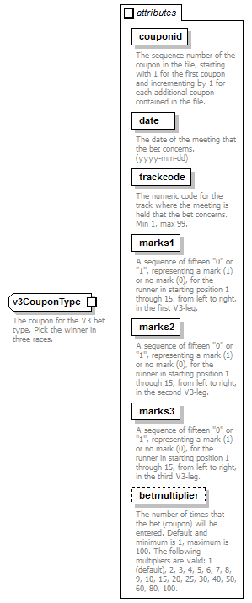
used by
  element | betcouponsType/v3Coupon
attributes
  Name | Type | Use | Default | Fixed | annotation
  couponid | derived by: xs:integer | required
    documentation
    The sequence number of the coupon in the file, starting with 1 for the first coupon and incrementing by 1 for each additional coupon contained in the file.
  date | xs:date | required
    documentation
    The date of the meeting that the bet concerns. (yyyy-mm-dd)
  trackcode | derived by: xs:integer | required
    documentation
    The numeric code for the track where the meeting is held that the bet concerns. Min 1, max 99.
  marks1 | derived by: xs:string | required
    documentation
    A sequence of fifteen "0" or "1", representing a mark (1) or no mark (0), for the runner in starting position 1 through 15, from left to right, in the first V3-leg.
  marks2 | derived by: xs:string | required
    documentation
    A sequence of fifteen "0" or "1", representing a mark (1) or no mark (0), for the runner in starting position 1 through 15, from left to right, in the second V3-leg.
  marks3 | derived by: xs:string | required
    documentation
    A sequence of fifteen "0" or "1", representing a mark (1) or no mark (0), for the runner in starting position 1 through 15, from left to right, in the third V3-leg.
  betmultiplier | derived by: xs:integer | optional | 1
    documentation
    The number of times that the bet (coupon) will be entered. Default and minimum is 1, maximum is 100. The following multipliers are valid: 1 (default), 2, 3, 4, 5, 6, 7, 8, 9, 10, 15, 20, 25, 30, 40, 50, 60, 80, 100.
annotation
  documentation
  The coupon for the V3 bet type. Pick the winner in three races.
source | <xs:complexType name="v3CouponType">  <xs:annotation>  <xs:documentation>The coupon for the V3 bet type. Pick the winner in three races.</xs:documentation>  </xs:annotation>  <xs:attribute name="couponid" use="required">  <xs:annotation>  <xs:documentation>The sequence number of the coupon in the file, starting with 1 for the first coupon and incrementing by 1 for each additional coupon contained in the file.</xs:documentation>  </xs:annotation>  <xs:simpleType>  <xs:restriction base="xs:integer">  <xs:minInclusive value="1"/>  <xs:maxInclusive value="9999"/>  </xs:restriction>  </xs:simpleType>  </xs:attribute>  <xs:attribute name="date" type="xs:date" use="required">  <xs:annotation>  <xs:documentation>The date of the meeting that the bet concerns. (yyyy-mm-dd)</xs:documentation>  </xs:annotation>  </xs:attribute>  <xs:attribute name="trackcode" use="required">  <xs:annotation>  <xs:documentation>The numeric code for the track where the meeting is held that the bet concerns. Min 1, max 99.</xs:documentation>  </xs:annotation>  <xs:simpleType>  <xs:restriction base="xs:integer">  <xs:minInclusive value="1"/>  <xs:maxInclusive value="99"/>  </xs:restriction>  </xs:simpleType>  </xs:attribute>  <xs:attribute name="marks1" use="required">  <xs:annotation>  <xs:documentation>A sequence of fifteen "0" or "1", representing a mark (1) or no mark (0), for the runner in starting position 1 through 15, from left to right, in the first V3-leg.</xs:documentation>  </xs:annotation>  <xs:simpleType>  <xs:restriction base="xs:string">  <xs:pattern value="[0-1]{15}"/>  </xs:restriction>  </xs:simpleType>  </xs:attribute>  <xs:attribute name="marks2" use="required">  <xs:annotation>  <xs:documentation>A sequence of fifteen "0" or "1", representing a mark (1) or no mark (0), for the runner in starting position 1 through 15, from left to right, in the second V3-leg.</xs:documentation>  </xs:annotation>  <xs:simpleType>  <xs:restriction base="xs:string">  <xs:pattern value="[0-1]{15}"/>  </xs:restriction>  </xs:simpleType>  </xs:attribute>  <xs:attribute name="marks3" use="required">  <xs:annotation>  <xs:documentation>A sequence of fifteen "0" or "1", representing a mark (1) or no mark (0), for the runner in starting position 1 through 15, from left to right, in the third V3-leg.</xs:documentation>  </xs:annotation>  <xs:simpleType>  <xs:restriction base="xs:string">  <xs:pattern value="[0-1]{15}"/>  </xs:restriction>  </xs:simpleType>  </xs:attribute>  <xs:attribute name="betmultiplier" use="optional" default="1">  <xs:annotation>  <xs:documentation>The number of times that the bet (coupon) will be entered. Default and minimum is 1, maximum is 100. The following multipliers are valid: 1 (default), 2, 3, 4, 5, 6, 7, 8, 9, 10, 15, 20, 25, 30, 40, 50, 60, 80, 100.</xs:documentation>  </xs:annotation>  <xs:simpleType>  <xs:restriction base="xs:integer">  <xs:minInclusive value="1"/>  <xs:maxInclusive value="100"/>  </xs:restriction>  </xs:simpleType>  </xs:attribute>  </xs:complexType>

attribute v3CouponType/@couponid
type | restriction of xs:integer
properties
  isRef | 0
  use | required
facets
  Kind | Value | annotation
  minInclusive | 1
  maxInclusive | 9999
annotation
  documentation
  The sequence number of the coupon in the file, starting with 1 for the first coupon and incrementing by 1 for each additional coupon contained in the file.
source | <xs:attribute name="couponid" use="required">  <xs:annotation>  <xs:documentation>The sequence number of the coupon in the file, starting with 1 for the first coupon and incrementing by 1 for each additional coupon contained in the file.</xs:documentation>  </xs:annotation>  <xs:simpleType>  <xs:restriction base="xs:integer">  <xs:minInclusive value="1"/>  <xs:maxInclusive value="9999"/>  </xs:restriction>  </xs:simpleType>  </xs:attribute>

attribute v3CouponType/@date
type | xs:date
properties
  isRef | 0
  use | required
annotation
  documentation
  The date of the meeting that the bet concerns. (yyyy-mm-dd)
source | <xs:attribute name="date" type="xs:date" use="required">  <xs:annotation>  <xs:documentation>The date of the meeting that the bet concerns. (yyyy-mm-dd)</xs:documentation>  </xs:annotation>  </xs:attribute>

attribute v3CouponType/@trackcode
type | restriction of xs:integer
properties
  isRef | 0
  use | required
facets
  Kind | Value | annotation
  minInclusive | 1
  maxInclusive | 99
annotation
  documentation
  The numeric code for the track where the meeting is held that the bet concerns. Min 1, max 99.
source | <xs:attribute name="trackcode" use="required">  <xs:annotation>  <xs:documentation>The numeric code for the track where the meeting is held that the bet concerns. Min 1, max 99.</xs:documentation>  </xs:annotation>  <xs:simpleType>  <xs:restriction base="xs:integer">  <xs:minInclusive value="1"/>  <xs:maxInclusive value="99"/>  </xs:restriction>  </xs:simpleType>  </xs:attribute>

attribute v3CouponType/@marks1
type | restriction of xs:string
properties
  isRef | 0
  use | required
facets
  Kind | Value | annotation
  pattern | [0-1]{15}
annotation
  documentation
  A sequence of fifteen "0" or "1", representing a mark (1) or no mark (0), for the runner in starting position 1 through 15, from left to right, in the first V3-leg.
source | <xs:attribute name="marks1" use="required">  <xs:annotation>  <xs:documentation>A sequence of fifteen "0" or "1", representing a mark (1) or no mark (0), for the runner in starting position 1 through 15, from left to right, in the first V3-leg.</xs:documentation>  </xs:annotation>  <xs:simpleType>  <xs:restriction base="xs:string">  <xs:pattern value="[0-1]{15}"/>  </xs:restriction>  </xs:simpleType>  </xs:attribute>

attribute v3CouponType/@marks2
type | restriction of xs:string
properties
  isRef | 0
  use | required
facets
  Kind | Value | annotation
  pattern | [0-1]{15}
annotation
  documentation
  A sequence of fifteen "0" or "1", representing a mark (1) or no mark (0), for the runner in starting position 1 through 15, from left to right, in the second V3-leg.
source | <xs:attribute name="marks2" use="required">  <xs:annotation>  <xs:documentation>A sequence of fifteen "0" or "1", representing a mark (1) or no mark (0), for the runner in starting position 1 through 15, from left to right, in the second V3-leg.</xs:documentation>  </xs:annotation>  <xs:simpleType>  <xs:restriction base="xs:string">  <xs:pattern value="[0-1]{15}"/>  </xs:restriction>  </xs:simpleType>  </xs:attribute>

attribute v3CouponType/@marks3
type | restriction of xs:string
properties
  isRef | 0
  use | required
facets
  Kind | Value | annotation
  pattern | [0-1]{15}
annotation
  documentation
  A sequence of fifteen "0" or "1", representing a mark (1) or no mark (0), for the runner in starting position 1 through 15, from left to right, in the third V3-leg.
source | <xs:attribute name="marks3" use="required">  <xs:annotation>  <xs:documentation>A sequence of fifteen "0" or "1", representing a mark (1) or no mark (0), for the runner in starting position 1 through 15, from left to right, in the third V3-leg.</xs:documentation>  </xs:annotation>  <xs:simpleType>  <xs:restriction base="xs:string">  <xs:pattern value="[0-1]{15}"/>  </xs:restriction>  </xs:simpleType>  </xs:attribute>

attribute v3CouponType/@betmultiplier
type | restriction of xs:integer
properties
  isRef | 0
  default | 1
  use | optional
facets
  Kind | Value | annotation
  minInclusive | 1
  maxInclusive | 100
annotation
  documentation
  The number of times that the bet (coupon) will be entered. Default and minimum is 1, maximum is 100. The following multipliers are valid: 1 (default), 2, 3, 4, 5, 6, 7, 8, 9, 10, 15, 20, 25, 30, 40, 50, 60, 80, 100.
source | <xs:attribute name="betmultiplier" use="optional" default="1">  <xs:annotation>  <xs:documentation>The number of times that the bet (coupon) will be entered. Default and minimum is 1, maximum is 100. The following multipliers are valid: 1 (default), 2, 3, 4, 5, 6, 7, 8, 9, 10, 15, 20, 25, 30, 40, 50, 60, 80, 100.</xs:documentation>  </xs:annotation>  <xs:simpleType>  <xs:restriction base="xs:integer">  <xs:minInclusive value="1"/>  <xs:maxInclusive value="100"/>  </xs:restriction>  </xs:simpleType>  </xs:attribute>

complexType v4CouponType
diagram | 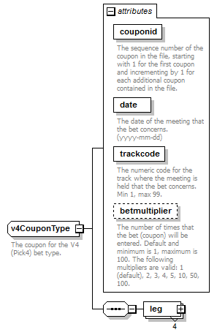
children | leg
used by
  element | betcouponsType/v4Coupon
attributes
  Name | Type | Use | Default | Fixed | annotation
  couponid | derived by: xs:integer | required
    documentation
    The sequence number of the coupon in the file, starting with 1 for the first coupon and incrementing by 1 for each additional coupon contained in the file.
  date | xs:date | required
    documentation
    The date of the meeting that the bet concerns. (yyyy-mm-dd)
  trackcode | derived by: xs:integer | required
    documentation
    The numeric code for the track where the meeting is held that the bet concerns. Min 1, max 99.
  betmultiplier | derived by: xs:integer | optional | 1
    documentation
    The number of times that the bet (coupon) will be entered. Default and minimum is 1, maximum is 100. The following multipliers are valid: 1 (default), 2, 3, 4, 5, 10, 50, 100.
annotation
  documentation
  The coupon for the V4 (Pick4) bet type.
source | <xs:complexType name="v4CouponType">  <xs:annotation>  <xs:documentation>The coupon for the V4 (Pick4) bet type.</xs:documentation>  </xs:annotation>  <xs:sequence>  <xs:element name="leg" type="legType20" minOccurs="4" maxOccurs="4"/>  </xs:sequence>  <xs:attribute name="couponid" use="required">  <xs:annotation>  <xs:documentation>The sequence number of the coupon in the file, starting with 1 for the first coupon and incrementing by 1 for each additional coupon contained in the file.</xs:documentation>  </xs:annotation>  <xs:simpleType>  <xs:restriction base="xs:integer">  <xs:minInclusive value="1"/>  <xs:maxInclusive value="9999"/>  </xs:restriction>  </xs:simpleType>  </xs:attribute>  <xs:attribute name="date" type="xs:date" use="required">  <xs:annotation>  <xs:documentation>The date of the meeting that the bet concerns. (yyyy-mm-dd)</xs:documentation>  </xs:annotation>  </xs:attribute>  <xs:attribute name="trackcode" use="required">  <xs:annotation>  <xs:documentation>The numeric code for the track where the meeting is held that the bet concerns. Min 1, max 99.</xs:documentation>  </xs:annotation>  <xs:simpleType>  <xs:restriction base="xs:integer">  <xs:minInclusive value="1"/>  <xs:maxInclusive value="99"/>  </xs:restriction>  </xs:simpleType>  </xs:attribute>  <xs:attribute name="betmultiplier" use="optional" default="1">  <xs:annotation>  <xs:documentation>The number of times that the bet (coupon) will be entered. Default and minimum is 1, maximum is 100. The following multipliers are valid: 1 (default), 2, 3, 4, 5, 10, 50, 100.</xs:documentation>  </xs:annotation>  <xs:simpleType>  <xs:restriction base="xs:integer">  <xs:minInclusive value="1"/>  <xs:maxInclusive value="100"/>  </xs:restriction>  </xs:simpleType>  </xs:attribute>  </xs:complexType>

attribute v4CouponType/@couponid
type | restriction of xs:integer
properties
  isRef | 0
  use | required
facets
  Kind | Value | annotation
  minInclusive | 1
  maxInclusive | 9999
annotation
  documentation
  The sequence number of the coupon in the file, starting with 1 for the first coupon and incrementing by 1 for each additional coupon contained in the file.
source | <xs:attribute name="couponid" use="required">  <xs:annotation>  <xs:documentation>The sequence number of the coupon in the file, starting with 1 for the first coupon and incrementing by 1 for each additional coupon contained in the file.</xs:documentation>  </xs:annotation>  <xs:simpleType>  <xs:restriction base="xs:integer">  <xs:minInclusive value="1"/>  <xs:maxInclusive value="9999"/>  </xs:restriction>  </xs:simpleType>  </xs:attribute>

attribute v4CouponType/@date
type | xs:date
properties
  isRef | 0
  use | required
annotation
  documentation
  The date of the meeting that the bet concerns. (yyyy-mm-dd)
source | <xs:attribute name="date" type="xs:date" use="required">  <xs:annotation>  <xs:documentation>The date of the meeting that the bet concerns. (yyyy-mm-dd)</xs:documentation>  </xs:annotation>  </xs:attribute>

attribute v4CouponType/@trackcode
type | restriction of xs:integer
properties
  isRef | 0
  use | required
facets
  Kind | Value | annotation
  minInclusive | 1
  maxInclusive | 99
annotation
  documentation
  The numeric code for the track where the meeting is held that the bet concerns. Min 1, max 99.
source | <xs:attribute name="trackcode" use="required">  <xs:annotation>  <xs:documentation>The numeric code for the track where the meeting is held that the bet concerns. Min 1, max 99.</xs:documentation>  </xs:annotation>  <xs:simpleType>  <xs:restriction base="xs:integer">  <xs:minInclusive value="1"/>  <xs:maxInclusive value="99"/>  </xs:restriction>  </xs:simpleType>  </xs:attribute>

attribute v4CouponType/@betmultiplier
type | restriction of xs:integer
properties
  isRef | 0
  default | 1
  use | optional
facets
  Kind | Value | annotation
  minInclusive | 1
  maxInclusive | 100
annotation
  documentation
  The number of times that the bet (coupon) will be entered. Default and minimum is 1, maximum is 100. The following multipliers are valid: 1 (default), 2, 3, 4, 5, 10, 50, 100.
source | <xs:attribute name="betmultiplier" use="optional" default="1">  <xs:annotation>  <xs:documentation>The number of times that the bet (coupon) will be entered. Default and minimum is 1, maximum is 100. The following multipliers are valid: 1 (default), 2, 3, 4, 5, 10, 50, 100.</xs:documentation>  </xs:annotation>  <xs:simpleType>  <xs:restriction base="xs:integer">  <xs:minInclusive value="1"/>  <xs:maxInclusive value="100"/>  </xs:restriction>  </xs:simpleType>  </xs:attribute>

element v4CouponType/leg
diagram | 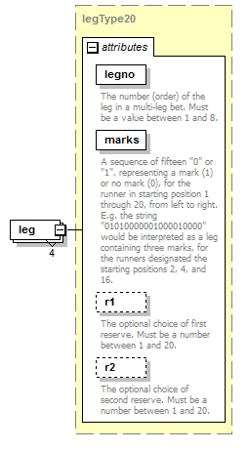
type | legType20
properties
  isRef | 0
  minOcc | 4
  maxOcc | 4
  content | complex
attributes
  Name | Type | Use | Default | Fixed | annotation
  legno | derived by: xs:integer | required
    documentation
    The number (order) of the leg in a multi-leg bet. Must be a value between 1 and 8.
  marks | derived by: xs:string | required
    documentation
    A sequence of fifteen "0" or "1", representing a mark (1) or no mark (0), for the runner in starting position 1 through 20, from left to right. E.g. the string "01010000001000010000" would be interpreted as a leg containing three marks, for the runners designated the starting positions 2, 4, and 16.
  r1 | derived by: xs:integer | optional
    documentation
    The optional choice of first reserve. Must be a number between 1 and 20.
  r2 | derived by: xs:integer | optional
    documentation
    The optional choice of second reserve. Must be a number between 1 and 20.
source | <xs:element name="leg" type="legType20" minOccurs="4" maxOccurs="4"/>

complexType v5CouponType
diagram | 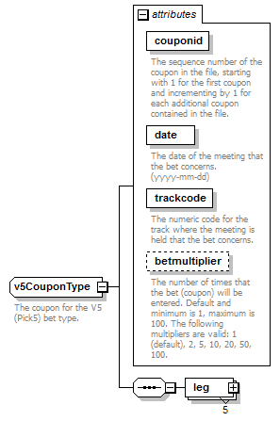
children | leg
used by
  element | betcouponsType/v5Coupon
attributes
  Name | Type | Use | Default | Fixed | annotation
  couponid | derived by: xs:integer | required
    documentation
    The sequence number of the coupon in the file, starting with 1 for the first coupon and incrementing by 1 for each additional coupon contained in the file.
  date | xs:date | required
    documentation
    The date of the meeting that the bet concerns. (yyyy-mm-dd)
  trackcode | derived by: xs:integer | required
    documentation
    The numeric code for the track where the meeting is held that the bet concerns.
  betmultiplier | derived by: xs:integer | optional | 1
    documentation
    The number of times that the bet (coupon) will be entered. Default and minimum is 1, maximum is 100. The following multipliers are valid: 1 (default), 2, 5, 10, 20, 50, 100.
annotation
  documentation
  The coupon for the V5 (Pick5) bet type.
source | <xs:complexType name="v5CouponType">  <xs:annotation>  <xs:documentation>The coupon for the V5 (Pick5) bet type.</xs:documentation>  </xs:annotation>  <xs:sequence>  <xs:element name="leg" type="legType" minOccurs="5" maxOccurs="5"/>  </xs:sequence>  <xs:attribute name="couponid" use="required">  <xs:annotation>  <xs:documentation>The sequence number of the coupon in the file, starting with 1 for the first coupon and incrementing by 1 for each additional coupon contained in the file.</xs:documentation>  </xs:annotation>  <xs:simpleType>  <xs:restriction base="xs:integer">  <xs:minInclusive value="1"/>  <xs:maxInclusive value="9999"/>  </xs:restriction>  </xs:simpleType>  </xs:attribute>  <xs:attribute name="date" type="xs:date" use="required">  <xs:annotation>  <xs:documentation>The date of the meeting that the bet concerns. (yyyy-mm-dd)</xs:documentation>  </xs:annotation>  </xs:attribute>  <xs:attribute name="trackcode" use="required">  <xs:annotation>  <xs:documentation>The numeric code for the track where the meeting is held that the bet concerns.</xs:documentation>  </xs:annotation>  <xs:simpleType>  <xs:restriction base="xs:integer">  <xs:minInclusive value="1"/>  <xs:maxInclusive value="99"/>  </xs:restriction>  </xs:simpleType>  </xs:attribute>  <xs:attribute name="betmultiplier" use="optional" default="1">  <xs:annotation>  <xs:documentation>The number of times that the bet (coupon) will be entered. Default and minimum is 1, maximum is 100. The following multipliers are valid: 1 (default), 2, 5, 10, 20, 50, 100.</xs:documentation>  </xs:annotation>  <xs:simpleType>  <xs:restriction base="xs:integer">  <xs:minInclusive value="1"/>  <xs:maxInclusive value="100"/>  </xs:restriction>  </xs:simpleType>  </xs:attribute>  </xs:complexType>

attribute v5CouponType/@couponid
type | restriction of xs:integer
properties
  isRef | 0
  use | required
facets
  Kind | Value | annotation
  minInclusive | 1
  maxInclusive | 9999
annotation
  documentation
  The sequence number of the coupon in the file, starting with 1 for the first coupon and incrementing by 1 for each additional coupon contained in the file.
source | <xs:attribute name="couponid" use="required">  <xs:annotation>  <xs:documentation>The sequence number of the coupon in the file, starting with 1 for the first coupon and incrementing by 1 for each additional coupon contained in the file.</xs:documentation>  </xs:annotation>  <xs:simpleType>  <xs:restriction base="xs:integer">  <xs:minInclusive value="1"/>  <xs:maxInclusive value="9999"/>  </xs:restriction>  </xs:simpleType>  </xs:attribute>

attribute v5CouponType/@date
type | xs:date
properties
  isRef | 0
  use | required
annotation
  documentation
  The date of the meeting that the bet concerns. (yyyy-mm-dd)
source | <xs:attribute name="date" type="xs:date" use="required">  <xs:annotation>  <xs:documentation>The date of the meeting that the bet concerns. (yyyy-mm-dd)</xs:documentation>  </xs:annotation>  </xs:attribute>

attribute v5CouponType/@trackcode
type | restriction of xs:integer
properties
  isRef | 0
  use | required
facets
  Kind | Value | annotation
  minInclusive | 1
  maxInclusive | 99
annotation
  documentation
  The numeric code for the track where the meeting is held that the bet concerns.
source | <xs:attribute name="trackcode" use="required">  <xs:annotation>  <xs:documentation>The numeric code for the track where the meeting is held that the bet concerns.</xs:documentation>  </xs:annotation>  <xs:simpleType>  <xs:restriction base="xs:integer">  <xs:minInclusive value="1"/>  <xs:maxInclusive value="99"/>  </xs:restriction>  </xs:simpleType>  </xs:attribute>

attribute v5CouponType/@betmultiplier
type | restriction of xs:integer
properties
  isRef | 0
  default | 1
  use | optional
facets
  Kind | Value | annotation
  minInclusive | 1
  maxInclusive | 100
annotation
  documentation
  The number of times that the bet (coupon) will be entered. Default and minimum is 1, maximum is 100. The following multipliers are valid: 1 (default), 2, 5, 10, 20, 50, 100.
source | <xs:attribute name="betmultiplier" use="optional" default="1">  <xs:annotation>  <xs:documentation>The number of times that the bet (coupon) will be entered. Default and minimum is 1, maximum is 100. The following multipliers are valid: 1 (default), 2, 5, 10, 20, 50, 100.</xs:documentation>  </xs:annotation>  <xs:simpleType>  <xs:restriction base="xs:integer">  <xs:minInclusive value="1"/>  <xs:maxInclusive value="100"/>  </xs:restriction>  </xs:simpleType>  </xs:attribute>

element v5CouponType/leg
diagram | 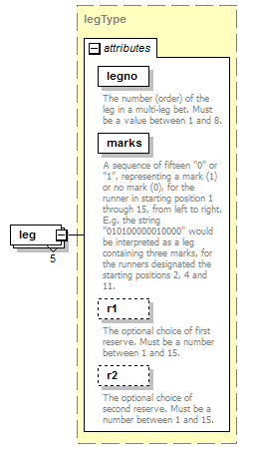
type | legType
properties
  isRef | 0
  minOcc | 5
  maxOcc | 5
  content | complex
attributes
  Name | Type | Use | Default | Fixed | annotation
  legno | derived by: xs:integer | required
    documentation
    The number (order) of the leg in a multi-leg bet. Must be a value between 1 and 8.
  marks | derived by: xs:string | required
    documentation
    A sequence of fifteen "0" or "1", representing a mark (1) or no mark (0), for the runner in starting position 1 through 15, from left to right. E.g. the string "010100000010000" would be interpreted as a leg containing three marks, for the runners designated the starting positions 2, 4 and 11.
  r1 | derived by: xs:integer | optional
    documentation
    The optional choice of first reserve. Must be a number between 1 and 15.
  r2 | derived by: xs:integer | optional
    documentation
    The optional choice of second reserve. Must be a number between 1 and 15.
source | <xs:element name="leg" type="legType" minOccurs="5" maxOccurs="5"/>

complexType v64CouponType
diagram | 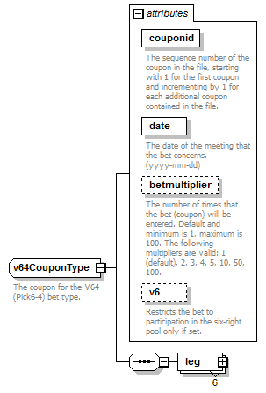
children | leg
used by
  element | betcouponsType/v64Coupon
attributes
  Name | Type | Use | Default | Fixed | annotation
  couponid | derived by: xs:integer | required
    documentation
    The sequence number of the coupon in the file, starting with 1 for the first coupon and incrementing by 1 for each additional coupon contained in the file.
  date | xs:date | required
    documentation
    The date of the meeting that the bet concerns. (yyyy-mm-dd)
  betmultiplier | derived by: xs:integer | optional | 1
    documentation
    The number of times that the bet (coupon) will be entered. Default and minimum is 1, maximum is 100. The following multipliers are valid: 1 (default), 2, 3, 4, 5, 10, 50, 100.
  v6 | xs:boolean | optional | 0
    documentation
    Restricts the bet to participation in the six-right pool only if set.
annotation
  documentation
  The coupon for the V64 (Pick6-4) bet type.
source | <xs:complexType name="v64CouponType">  <xs:annotation>  <xs:documentation>The coupon for the V64 (Pick6-4) bet type.</xs:documentation>  </xs:annotation>  <xs:sequence>  <xs:element name="leg" type="legType" minOccurs="6" maxOccurs="6"/>  </xs:sequence>  <xs:attribute name="couponid" use="required">  <xs:annotation>  <xs:documentation>The sequence number of the coupon in the file, starting with 1 for the first coupon and incrementing by 1 for each additional coupon contained in the file.</xs:documentation>  </xs:annotation>  <xs:simpleType>  <xs:restriction base="xs:integer">  <xs:minInclusive value="1"/>  <xs:maxInclusive value="9999"/>  </xs:restriction>  </xs:simpleType>  </xs:attribute>  <xs:attribute name="date" type="xs:date" use="required">  <xs:annotation>  <xs:documentation>The date of the meeting that the bet concerns. (yyyy-mm-dd)</xs:documentation>  </xs:annotation>  </xs:attribute>  <xs:attribute name="betmultiplier" use="optional" default="1">  <xs:annotation>  <xs:documentation>The number of times that the bet (coupon) will be entered. Default and minimum is 1, maximum is 100. The following multipliers are valid: 1 (default), 2, 3, 4, 5, 10, 50, 100.</xs:documentation>  </xs:annotation>  <xs:simpleType>  <xs:restriction base="xs:integer">  <xs:minInclusive value="1"/>  <xs:maxInclusive value="100"/>  </xs:restriction>  </xs:simpleType>  </xs:attribute>  <xs:attribute name="v6" type="xs:boolean" use="optional" default="0">  <xs:annotation>  <xs:documentation>Restricts the bet to participation in the six-right pool only if set.</xs:documentation>  </xs:annotation>  </xs:attribute>  </xs:complexType>

attribute v64CouponType/@couponid
type | restriction of xs:integer
properties
  isRef | 0
  use | required
facets
  Kind | Value | annotation
  minInclusive | 1
  maxInclusive | 9999
annotation
  documentation
  The sequence number of the coupon in the file, starting with 1 for the first coupon and incrementing by 1 for each additional coupon contained in the file.
source | <xs:attribute name="couponid" use="required">  <xs:annotation>  <xs:documentation>The sequence number of the coupon in the file, starting with 1 for the first coupon and incrementing by 1 for each additional coupon contained in the file.</xs:documentation>  </xs:annotation>  <xs:simpleType>  <xs:restriction base="xs:integer">  <xs:minInclusive value="1"/>  <xs:maxInclusive value="9999"/>  </xs:restriction>  </xs:simpleType>  </xs:attribute>

attribute v64CouponType/@date
type | xs:date
properties
  isRef | 0
  use | required
annotation
  documentation
  The date of the meeting that the bet concerns. (yyyy-mm-dd)
source | <xs:attribute name="date" type="xs:date" use="required">  <xs:annotation>  <xs:documentation>The date of the meeting that the bet concerns. (yyyy-mm-dd)</xs:documentation>  </xs:annotation>  </xs:attribute>

attribute v64CouponType/@betmultiplier
type | restriction of xs:integer
properties
  isRef | 0
  default | 1
  use | optional
facets
  Kind | Value | annotation
  minInclusive | 1
  maxInclusive | 100
annotation
  documentation
  The number of times that the bet (coupon) will be entered. Default and minimum is 1, maximum is 100. The following multipliers are valid: 1 (default), 2, 3, 4, 5, 10, 50, 100.
source | <xs:attribute name="betmultiplier" use="optional" default="1">  <xs:annotation>  <xs:documentation>The number of times that the bet (coupon) will be entered. Default and minimum is 1, maximum is 100. The following multipliers are valid: 1 (default), 2, 3, 4, 5, 10, 50, 100.</xs:documentation>  </xs:annotation>  <xs:simpleType>  <xs:restriction base="xs:integer">  <xs:minInclusive value="1"/>  <xs:maxInclusive value="100"/>  </xs:restriction>  </xs:simpleType>  </xs:attribute>

attribute v64CouponType/@v6
type | xs:boolean
properties
  isRef | 0
  default | 0
  use | optional
annotation
  documentation
  Restricts the bet to participation in the six-right pool only if set.
source | <xs:attribute name="v6" type="xs:boolean" use="optional" default="0">  <xs:annotation>  <xs:documentation>Restricts the bet to participation in the six-right pool only if set.</xs:documentation>  </xs:annotation>  </xs:attribute>

element v64CouponType/leg
diagram | 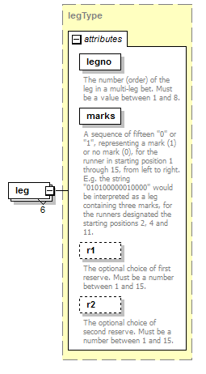
type | legType
properties
  isRef | 0
  minOcc | 6
  maxOcc | 6
  content | complex
attributes
  Name | Type | Use | Default | Fixed | annotation
  legno | derived by: xs:integer | required
    documentation
    The number (order) of the leg in a multi-leg bet. Must be a value between 1 and 8.
  marks | derived by: xs:string | required
    documentation
    A sequence of fifteen "0" or "1", representing a mark (1) or no mark (0), for the runner in starting position 1 through 15, from left to right. E.g. the string "010100000010000" would be interpreted as a leg containing three marks, for the runners designated the starting positions 2, 4 and 11.
  r1 | derived by: xs:integer | optional
    documentation
    The optional choice of first reserve. Must be a number between 1 and 15.
  r2 | derived by: xs:integer | optional
    documentation
    The optional choice of second reserve. Must be a number between 1 and 15.
source | <xs:element name="leg" type="legType" minOccurs="6" maxOccurs="6"/>

complexType v65CouponType
diagram | 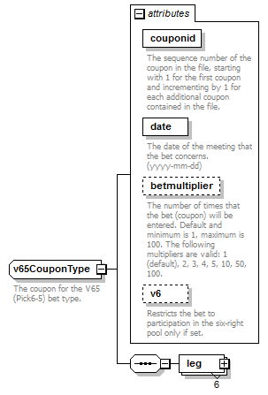
children | leg
used by
  element | betcouponsType/v65Coupon
attributes
  Name | Type | Use | Default | Fixed | annotation
  couponid | derived by: xs:integer | required
    documentation
    The sequence number of the coupon in the file, starting with 1 for the first coupon and incrementing by 1 for each additional coupon contained in the file.
  date | xs:date | required
    documentation
    The date of the meeting that the bet concerns. (yyyy-mm-dd)
  betmultiplier | derived by: xs:integer | optional | 1
    documentation
    The number of times that the bet (coupon) will be entered. Default and minimum is 1, maximum is 100. The following multipliers are valid: 1 (default), 2, 3, 4, 5, 10, 50, 100.
  v6 | xs:boolean | optional | 0
    documentation
    Restricts the bet to participation in the six-right pool only if set.
annotation
  documentation
  The coupon for the V65 (Pick6-5) bet type.
source | <xs:complexType name="v65CouponType">  <xs:annotation>  <xs:documentation>The coupon for the V65 (Pick6-5) bet type.</xs:documentation>  </xs:annotation>  <xs:sequence>  <xs:element name="leg" type="legType" minOccurs="6" maxOccurs="6"/>  </xs:sequence>  <xs:attribute name="couponid" use="required">  <xs:annotation>  <xs:documentation>The sequence number of the coupon in the file, starting with 1 for the first coupon and incrementing by 1 for each additional coupon contained in the file.</xs:documentation>  </xs:annotation>  <xs:simpleType>  <xs:restriction base="xs:integer">  <xs:minInclusive value="1"/>  <xs:maxInclusive value="9999"/>  </xs:restriction>  </xs:simpleType>  </xs:attribute>  <xs:attribute name="date" type="xs:date" use="required">  <xs:annotation>  <xs:documentation>The date of the meeting that the bet concerns. (yyyy-mm-dd)</xs:documentation>  </xs:annotation>  </xs:attribute>  <xs:attribute name="betmultiplier" use="optional" default="1">  <xs:annotation>  <xs:documentation>The number of times that the bet (coupon) will be entered. Default and minimum is 1, maximum is 100. The following multipliers are valid: 1 (default), 2, 3, 4, 5, 10, 50, 100.</xs:documentation>  </xs:annotation>  <xs:simpleType>  <xs:restriction base="xs:integer">  <xs:minInclusive value="1"/>  <xs:maxInclusive value="100"/>  </xs:restriction>  </xs:simpleType>  </xs:attribute>  <xs:attribute name="v6" type="xs:boolean" use="optional" default="0">  <xs:annotation>  <xs:documentation>Restricts the bet to participation in the six-right pool only if set.</xs:documentation>  </xs:annotation>  </xs:attribute>  </xs:complexType>

attribute v65CouponType/@couponid
type | restriction of xs:integer
properties
  isRef | 0
  use | required
facets
  Kind | Value | annotation
  minInclusive | 1
  maxInclusive | 9999
annotation
  documentation
  The sequence number of the coupon in the file, starting with 1 for the first coupon and incrementing by 1 for each additional coupon contained in the file.
source | <xs:attribute name="couponid" use="required">  <xs:annotation>  <xs:documentation>The sequence number of the coupon in the file, starting with 1 for the first coupon and incrementing by 1 for each additional coupon contained in the file.</xs:documentation>  </xs:annotation>  <xs:simpleType>  <xs:restriction base="xs:integer">  <xs:minInclusive value="1"/>  <xs:maxInclusive value="9999"/>  </xs:restriction>  </xs:simpleType>  </xs:attribute>

attribute v65CouponType/@date
type | xs:date
properties
  isRef | 0
  use | required
annotation
  documentation
  The date of the meeting that the bet concerns. (yyyy-mm-dd)
source | <xs:attribute name="date" type="xs:date" use="required">  <xs:annotation>  <xs:documentation>The date of the meeting that the bet concerns. (yyyy-mm-dd)</xs:documentation>  </xs:annotation>  </xs:attribute>

attribute v65CouponType/@betmultiplier
type | restriction of xs:integer
properties
  isRef | 0
  default | 1
  use | optional
facets
  Kind | Value | annotation
  minInclusive | 1
  maxInclusive | 100
annotation
  documentation
  The number of times that the bet (coupon) will be entered. Default and minimum is 1, maximum is 100. The following multipliers are valid: 1 (default), 2, 3, 4, 5, 10, 50, 100.
source | <xs:attribute name="betmultiplier" use="optional" default="1">  <xs:annotation>  <xs:documentation>The number of times that the bet (coupon) will be entered. Default and minimum is 1, maximum is 100. The following multipliers are valid: 1 (default), 2, 3, 4, 5, 10, 50, 100.</xs:documentation>  </xs:annotation>  <xs:simpleType>  <xs:restriction base="xs:integer">  <xs:minInclusive value="1"/>  <xs:maxInclusive value="100"/>  </xs:restriction>  </xs:simpleType>  </xs:attribute>

attribute v65CouponType/@v6
type | xs:boolean
properties
  isRef | 0
  default | 0
  use | optional
annotation
  documentation
  Restricts the bet to participation in the six-right pool only if set.
source | <xs:attribute name="v6" type="xs:boolean" use="optional" default="0">  <xs:annotation>  <xs:documentation>Restricts the bet to participation in the six-right pool only if set.</xs:documentation>  </xs:annotation>  </xs:attribute>

element v65CouponType/leg
diagram
type | legType
properties
  isRef | 0
  minOcc | 6
  maxOcc | 6
  content | complex
attributes
  Name | Type | Use | Default | Fixed | annotation
  legno | derived by: xs:integer | required
    documentation
    The number (order) of the leg in a multi-leg bet. Must be a value between 1 and 8.
  marks | derived by: xs:string | required
    documentation
    A sequence of fifteen "0" or "1", representing a mark (1) or no mark (0), for the runner in starting position 1 through 15, from left to right. E.g. the string "010100000010000" would be interpreted as a leg containing three marks, for the runners designated the starting positions 2, 4 and 11.
  r1 | derived by: xs:integer | optional
    documentation
    The optional choice of first reserve. Must be a number between 1 and 15.
  r2 | derived by: xs:integer | optional
    documentation
    The optional choice of second reserve. Must be a number between 1 and 15.
source | <xs:element name="leg" type="legType" minOccurs="6" maxOccurs="6"/>

complexType v75CouponType
diagram | 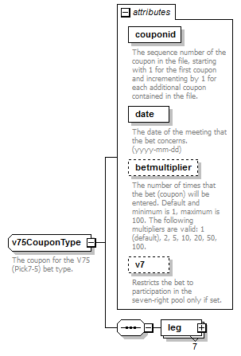
children | leg
used by
  element | betcouponsType/v75Coupon
attributes
  Name | Type | Use | Default | Fixed | annotation
  couponid | derived by: xs:integer | required
    documentation
    The sequence number of the coupon in the file, starting with 1 for the first coupon and incrementing by 1 for each additional coupon contained in the file.
  date | xs:date | required
    documentation
    The date of the meeting that the bet concerns. (yyyy-mm-dd)
  betmultiplier | derived by: xs:integer | optional | 1
    documentation
    The number of times that the bet (coupon) will be entered. Default and minimum is 1, maximum is 100. The following multipliers are valid: 1 (default), 2, 5, 10, 20, 50, 100.
  v7 | xs:boolean | optional | 0
    documentation
    Restricts the bet to participation in the seven-right pool only if set.
annotation
  documentation
  The coupon for the V75 (Pick7-5) bet type.
source | <xs:complexType name="v75CouponType">  <xs:annotation>  <xs:documentation>The coupon for the V75 (Pick7-5) bet type.</xs:documentation>  </xs:annotation>  <xs:sequence>  <xs:element name="leg" type="legType" minOccurs="7" maxOccurs="7"/>  </xs:sequence>  <xs:attribute name="couponid" use="required">  <xs:annotation>  <xs:documentation>The sequence number of the coupon in the file, starting with 1 for the first coupon and incrementing by 1 for each additional coupon contained in the file.</xs:documentation>  </xs:annotation>  <xs:simpleType>  <xs:restriction base="xs:integer">  <xs:minInclusive value="1"/>  <xs:maxInclusive value="9999"/>  </xs:restriction>  </xs:simpleType>  </xs:attribute>  <xs:attribute name="date" type="xs:date" use="required">  <xs:annotation>  <xs:documentation>The date of the meeting that the bet concerns. (yyyy-mm-dd)</xs:documentation>  </xs:annotation>  </xs:attribute>  <xs:attribute name="betmultiplier" use="optional" default="1">  <xs:annotation>  <xs:documentation>The number of times that the bet (coupon) will be entered. Default and minimum is 1, maximum is 100. The following multipliers are valid: 1 (default), 2, 5, 10, 20, 50, 100.</xs:documentation>  </xs:annotation>  <xs:simpleType>  <xs:restriction base="xs:integer">  <xs:minInclusive value="1"/>  <xs:maxInclusive value="100"/>  </xs:restriction>  </xs:simpleType>  </xs:attribute>  <xs:attribute name="v7" type="xs:boolean" use="optional" default="0">  <xs:annotation>  <xs:documentation>Restricts the bet to participation in the seven-right pool only if set.</xs:documentation>  </xs:annotation>  </xs:attribute>  </xs:complexType>

attribute v75CouponType/@couponid
type | restriction of xs:integer
properties
  isRef | 0
  use | required
facets
  Kind | Value | annotation
  minInclusive | 1
  maxInclusive | 9999
annotation
  documentation
  The sequence number of the coupon in the file, starting with 1 for the first coupon and incrementing by 1 for each additional coupon contained in the file.
source | <xs:attribute name="couponid" use="required">  <xs:annotation>  <xs:documentation>The sequence number of the coupon in the file, starting with 1 for the first coupon and incrementing by 1 for each additional coupon contained in the file.</xs:documentation>  </xs:annotation>  <xs:simpleType>  <xs:restriction base="xs:integer">  <xs:minInclusive value="1"/>  <xs:maxInclusive value="9999"/>  </xs:restriction>  </xs:simpleType>  </xs:attribute>

attribute v75CouponType/@date
type | xs:date
properties
  isRef | 0
  use | required
annotation
  documentation
  The date of the meeting that the bet concerns. (yyyy-mm-dd)
source | <xs:attribute name="date" type="xs:date" use="required">  <xs:annotation>  <xs:documentation>The date of the meeting that the bet concerns. (yyyy-mm-dd)</xs:documentation>  </xs:annotation>  </xs:attribute>

attribute v75CouponType/@betmultiplier
type | restriction of xs:integer
properties
  isRef | 0
  default | 1
  use | optional
facets
  Kind | Value | annotation
  minInclusive | 1
  maxInclusive | 100
annotation
  documentation
  The number of times that the bet (coupon) will be entered. Default and minimum is 1, maximum is 100. The following multipliers are valid: 1 (default), 2, 5, 10, 20, 50, 100.
source | <xs:attribute name="betmultiplier" use="optional" default="1">  <xs:annotation>  <xs:documentation>The number of times that the bet (coupon) will be entered. Default and minimum is 1, maximum is 100. The following multipliers are valid: 1 (default), 2, 5, 10, 20, 50, 100.</xs:documentation>  </xs:annotation>  <xs:simpleType>  <xs:restriction base="xs:integer">  <xs:minInclusive value="1"/>  <xs:maxInclusive value="100"/>  </xs:restriction>  </xs:simpleType>  </xs:attribute>

attribute v75CouponType/@v7
type | xs:boolean
properties
  isRef | 0
  default | 0
  use | optional
annotation
  documentation
  Restricts the bet to participation in the seven-right pool only if set.
source | <xs:attribute name="v7" type="xs:boolean" use="optional" default="0">  <xs:annotation>  <xs:documentation>Restricts the bet to participation in the seven-right pool only if set.</xs:documentation>  </xs:annotation>  </xs:attribute>

element v75CouponType/leg
diagram | 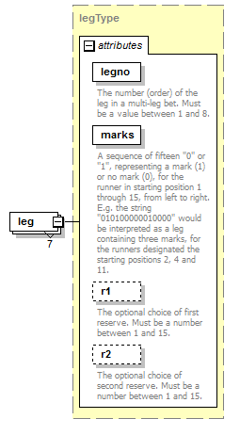
type | legType
properties
  isRef | 0
  minOcc | 7
  maxOcc | 7
  content | complex
attributes
  Name | Type | Use | Default | Fixed | annotation
  legno | derived by: xs:integer | required
    documentation
    The number (order) of the leg in a multi-leg bet. Must be a value between 1 and 8.
  marks | derived by: xs:string | required
    documentation
    A sequence of fifteen "0" or "1", representing a mark (1) or no mark (0), for the runner in starting position 1 through 15, from left to right. E.g. the string "010100000010000" would be interpreted as a leg containing three marks, for the runners designated the starting positions 2, 4 and 11.
  r1 | derived by: xs:integer | optional
    documentation
    The optional choice of first reserve. Must be a number between 1 and 15.
  r2 | derived by: xs:integer | optional
    documentation
    The optional choice of second reserve. Must be a number between 1 and 15.
source | <xs:element name="leg" type="legType" minOccurs="7" maxOccurs="7"/>

complexType v86CouponType
diagram | 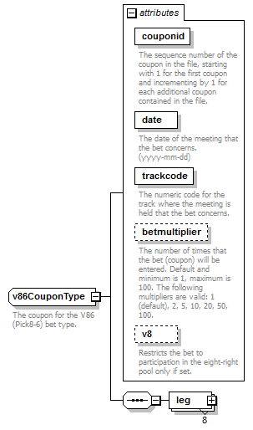
children | leg
used by
  element | betcouponsType/v86Coupon
attributes
  Name | Type | Use | Default | Fixed | annotation
  couponid | derived by: xs:integer | required
    documentation
    The sequence number of the coupon in the file, starting with 1 for the first coupon and incrementing by 1 for each additional coupon contained in the file.
  date | xs:date | required
    documentation
    The date of the meeting that the bet concerns. (yyyy-mm-dd)
  trackcode | derived by: xs:integer | required
    documentation
    The numeric code for the track where the meeting is held that the bet concerns.
  betmultiplier | derived by: xs:integer | optional | 1
    documentation
    The number of times that the bet (coupon) will be entered. Default and minimum is 1, maximum is 100. The following multipliers are valid: 1 (default), 2, 5, 10, 20, 50, 100.
  v8 | xs:boolean | optional | 0
    documentation
    Restricts the bet to participation in the eight-right pool only if set.
annotation
  documentation
  The coupon for the V86 (Pick8-6) bet type.
source | <xs:complexType name="v86CouponType">  <xs:annotation>  <xs:documentation>The coupon for the V86 (Pick8-6) bet type.</xs:documentation>  </xs:annotation>  <xs:sequence>  <xs:element name="leg" type="legType" minOccurs="8" maxOccurs="8"/>  </xs:sequence>  <xs:attribute name="couponid" use="required">  <xs:annotation>  <xs:documentation>The sequence number of the coupon in the file, starting with 1 for the first coupon and incrementing by 1 for each additional coupon contained in the file.</xs:documentation>  </xs:annotation>  <xs:simpleType>  <xs:restriction base="xs:integer">  <xs:minInclusive value="1"/>  <xs:maxInclusive value="9999"/>  </xs:restriction>  </xs:simpleType>  </xs:attribute>  <xs:attribute name="date" type="xs:date" use="required">  <xs:annotation>  <xs:documentation>The date of the meeting that the bet concerns. (yyyy-mm-dd)</xs:documentation>  </xs:annotation>  </xs:attribute>  <xs:attribute name="trackcode" use="required">  <xs:annotation>  <xs:documentation>The numeric code for the track where the meeting is held that the bet concerns.</xs:documentation>  </xs:annotation>  <xs:simpleType>  <xs:restriction base="xs:integer">  <xs:minInclusive value="1"/>  <xs:maxInclusive value="99"/>  </xs:restriction>  </xs:simpleType>  </xs:attribute>  <xs:attribute name="betmultiplier" use="optional" default="1">  <xs:annotation>  <xs:documentation>The number of times that the bet (coupon) will be entered. Default and minimum is 1, maximum is 100. The following multipliers are valid: 1 (default), 2, 5, 10, 20, 50, 100.</xs:documentation>  </xs:annotation>  <xs:simpleType>  <xs:restriction base="xs:integer">  <xs:minInclusive value="1"/>  <xs:maxInclusive value="100"/>  </xs:restriction>  </xs:simpleType>  </xs:attribute>  <xs:attribute name="v8" type="xs:boolean" use="optional" default="0">  <xs:annotation>  <xs:documentation>Restricts the bet to participation in the eight-right pool only if set.</xs:documentation>  </xs:annotation>  </xs:attribute>  </xs:complexType>

attribute v86CouponType/@couponid
type | restriction of xs:integer
properties
  isRef | 0
  use | required
facets
  Kind | Value | annotation
  minInclusive | 1
  maxInclusive | 9999
annotation
  documentation
  The sequence number of the coupon in the file, starting with 1 for the first coupon and incrementing by 1 for each additional coupon contained in the file.
source | <xs:attribute name="couponid" use="required">  <xs:annotation>  <xs:documentation>The sequence number of the coupon in the file, starting with 1 for the first coupon and incrementing by 1 for each additional coupon contained in the file.</xs:documentation>  </xs:annotation>  <xs:simpleType>  <xs:restriction base="xs:integer">  <xs:minInclusive value="1"/>  <xs:maxInclusive value="9999"/>  </xs:restriction>  </xs:simpleType>  </xs:attribute>

attribute v86CouponType/@date
type | xs:date
properties
  isRef | 0
  use | required
annotation
  documentation
  The date of the meeting that the bet concerns. (yyyy-mm-dd)
source | <xs:attribute name="date" type="xs:date" use="required">  <xs:annotation>  <xs:documentation>The date of the meeting that the bet concerns. (yyyy-mm-dd)</xs:documentation>  </xs:annotation>  </xs:attribute>

attribute v86CouponType/@trackcode
type | restriction of xs:integer
properties
  isRef | 0
  use | required
facets
  Kind | Value | annotation
  minInclusive | 1
  maxInclusive | 99
annotation
  documentation
  The numeric code for the track where the meeting is held that the bet concerns.
source | <xs:attribute name="trackcode" use="required">  <xs:annotation>  <xs:documentation>The numeric code for the track where the meeting is held that the bet concerns.</xs:documentation>  </xs:annotation>  <xs:simpleType>  <xs:restriction base="xs:integer">  <xs:minInclusive value="1"/>  <xs:maxInclusive value="99"/>  </xs:restriction>  </xs:simpleType>  </xs:attribute>

attribute v86CouponType/@betmultiplier
type | restriction of xs:integer
properties
  isRef | 0
  default | 1
  use | optional
facets
  Kind | Value | annotation
  minInclusive | 1
  maxInclusive | 100
annotation
  documentation
  The number of times that the bet (coupon) will be entered. Default and minimum is 1, maximum is 100. The following multipliers are valid: 1 (default), 2, 5, 10, 20, 50, 100.
source | <xs:attribute name="betmultiplier" use="optional" default="1">  <xs:annotation>  <xs:documentation>The number of times that the bet (coupon) will be entered. Default and minimum is 1, maximum is 100. The following multipliers are valid: 1 (default), 2, 5, 10, 20, 50, 100.</xs:documentation>  </xs:annotation>  <xs:simpleType>  <xs:restriction base="xs:integer">  <xs:minInclusive value="1"/>  <xs:maxInclusive value="100"/>  </xs:restriction>  </xs:simpleType>  </xs:attribute>

attribute v86CouponType/@v8
type | xs:boolean
properties
  isRef | 0
  default | 0
  use | optional
annotation
  documentation
  Restricts the bet to participation in the eight-right pool only if set.
source | <xs:attribute name="v8" type="xs:boolean" use="optional" default="0">  <xs:annotation>  <xs:documentation>Restricts the bet to participation in the eight-right pool only if set.</xs:documentation>  </xs:annotation>  </xs:attribute>

element v86CouponType/leg
diagram | 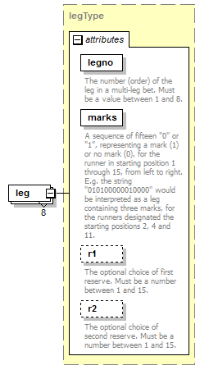
type | legType
properties
  isRef | 0
  minOcc | 8
  maxOcc | 8
  content | complex
attributes
  Name | Type | Use | Default | Fixed | annotation
  legno | derived by: xs:integer | required
    documentation
    The number (order) of the leg in a multi-leg bet. Must be a value between 1 and 8.
  marks | derived by: xs:string | required
    documentation
    A sequence of fifteen "0" or "1", representing a mark (1) or no mark (0), for the runner in starting position 1 through 15, from left to right. E.g. the string "010100000010000" would be interpreted as a leg containing three marks, for the runners designated the starting positions 2, 4 and 11.
  r1 | derived by: xs:integer | optional
    documentation
    The optional choice of first reserve. Must be a number between 1 and 15.
  r2 | derived by: xs:integer | optional
    documentation
    The optional choice of second reserve. Must be a number between 1 and 15.
source | <xs:element name="leg" type="legType" minOccurs="8" maxOccurs="8"/>

complexType VPCouponType
diagram | 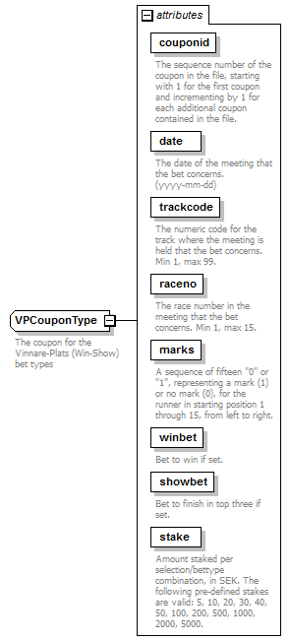
used by
  element | betcouponsType/VPCoupon
attributes
  Name | Type | Use | Default | Fixed | annotation
  couponid | derived by: xs:integer | required
    documentation
    The sequence number of the coupon in the file, starting with 1 for the first coupon and incrementing by 1 for each additional coupon contained in the file.
  date | xs:date | required
    documentation
    The date of the meeting that the bet concerns. (yyyy-mm-dd)
  trackcode | derived by: xs:integer | required
    documentation
    The numeric code for the track where the meeting is held that the bet concerns. Min 1, max 99.
  raceno | derived by: xs:integer | required
    documentation
    The race number in the meeting that the bet concerns. Min 1, max 15.
  marks | derived by: xs:string | required
    documentation
    A sequence of fifteen "0" or "1", representing a mark (1) or no mark (0), for the runner in starting position 1 through 15, from left to right.
  winbet | xs:boolean | required
    documentation
    Bet to win if set.
  showbet | xs:boolean | required
    documentation
    Bet to finish in top three if set.
  stake | derived by: xs:integer | required
    documentation
    Amount staked per selection/bettype combination, in SEK. The following pre-defined stakes are valid: 5, 10, 20, 30, 40, 50, 100, 200, 500, 1000, 2000, 5000.
annotation
  documentation
  The coupon for the Vinnare-Plats (Win-Show) bet types
source | <xs:complexType name="VPCouponType">  <xs:annotation>  <xs:documentation>The coupon for the Vinnare-Plats (Win-Show) bet types</xs:documentation>  </xs:annotation>  <xs:attribute name="couponid" use="required">  <xs:annotation>  <xs:documentation>The sequence number of the coupon in the file, starting with 1 for the first coupon and incrementing by 1 for each additional coupon contained in the file.</xs:documentation>  </xs:annotation>  <xs:simpleType>  <xs:restriction base="xs:integer">  <xs:minInclusive value="1"/>  <xs:maxInclusive value="9999"/>  </xs:restriction>  </xs:simpleType>  </xs:attribute>  <xs:attribute name="date" type="xs:date" use="required">  <xs:annotation>  <xs:documentation>The date of the meeting that the bet concerns. (yyyy-mm-dd)</xs:documentation>  </xs:annotation>  </xs:attribute>  <xs:attribute name="trackcode" use="required">  <xs:annotation>  <xs:documentation>The numeric code for the track where the meeting is held that the bet concerns. Min 1, max 99.</xs:documentation>  </xs:annotation>  <xs:simpleType>  <xs:restriction base="xs:integer">  <xs:minInclusive value="1"/>  <xs:maxInclusive value="99"/>  </xs:restriction>  </xs:simpleType>  </xs:attribute>  <xs:attribute name="raceno" use="required">  <xs:annotation>  <xs:documentation>The race number in the meeting that the bet concerns. Min 1, max 15.</xs:documentation>  </xs:annotation>  <xs:simpleType>  <xs:restriction base="xs:integer">  <xs:minInclusive value="1"/>  <xs:maxInclusive value="15"/>  </xs:restriction>  </xs:simpleType>  </xs:attribute>  <xs:attribute name="marks" use="required">  <xs:annotation>  <xs:documentation>A sequence of fifteen "0" or "1", representing a mark (1) or no mark (0), for the runner in starting position 1 through 15, from left to right.</xs:documentation>  </xs:annotation>  <xs:simpleType>  <xs:restriction base="xs:string">  <xs:pattern value="[0-1]{15}"/>  </xs:restriction>  </xs:simpleType>  </xs:attribute>  <xs:attribute name="winbet" type="xs:boolean" use="required">  <xs:annotation>  <xs:documentation>Bet to win if set.</xs:documentation>  </xs:annotation>  </xs:attribute>  <xs:attribute name="showbet" type="xs:boolean" use="required">  <xs:annotation>  <xs:documentation>Bet to finish in top three if set.</xs:documentation>  </xs:annotation>  </xs:attribute>  <xs:attribute name="stake" use="required">  <xs:annotation>  <xs:documentation>Amount staked per selection/bettype combination, in SEK. The following pre-defined stakes are valid: 5, 10, 20, 30, 40, 50, 100, 200, 500, 1000, 2000, 5000.</xs:documentation>  </xs:annotation>  <xs:simpleType>  <xs:restriction base="xs:integer">  <xs:maxInclusive value="5000"/>  <xs:minInclusive value="5"/>  </xs:restriction>  </xs:simpleType>  </xs:attribute>  </xs:complexType>

attribute VPCouponType/@couponid
type | restriction of xs:integer
properties
  isRef | 0
  use | required
facets
  Kind | Value | annotation
  minInclusive | 1
  maxInclusive | 9999
annotation
  documentation
  The sequence number of the coupon in the file, starting with 1 for the first coupon and incrementing by 1 for each additional coupon contained in the file.
source | <xs:attribute name="couponid" use="required">  <xs:annotation>  <xs:documentation>The sequence number of the coupon in the file, starting with 1 for the first coupon and incrementing by 1 for each additional coupon contained in the file.</xs:documentation>  </xs:annotation>  <xs:simpleType>  <xs:restriction base="xs:integer">  <xs:minInclusive value="1"/>  <xs:maxInclusive value="9999"/>  </xs:restriction>  </xs:simpleType>  </xs:attribute>

attribute VPCouponType/@date
type | xs:date
properties
  isRef | 0
  use | required
annotation
  documentation
  The date of the meeting that the bet concerns. (yyyy-mm-dd)
source | <xs:attribute name="date" type="xs:date" use="required">  <xs:annotation>  <xs:documentation>The date of the meeting that the bet concerns. (yyyy-mm-dd)</xs:documentation>  </xs:annotation>  </xs:attribute>

attribute VPCouponType/@trackcode
type | restriction of xs:integer
properties
  isRef | 0
  use | required
facets
  Kind | Value | annotation
  minInclusive | 1
  maxInclusive | 99
annotation
  documentation
  The numeric code for the track where the meeting is held that the bet concerns. Min 1, max 99.
source | <xs:attribute name="trackcode" use="required">  <xs:annotation>  <xs:documentation>The numeric code for the track where the meeting is held that the bet concerns. Min 1, max 99.</xs:documentation>  </xs:annotation>  <xs:simpleType>  <xs:restriction base="xs:integer">  <xs:minInclusive value="1"/>  <xs:maxInclusive value="99"/>  </xs:restriction>  </xs:simpleType>  </xs:attribute>

attribute VPCouponType/@raceno
type | restriction of xs:integer
properties
  isRef | 0
  use | required
facets
  Kind | Value | annotation
  minInclusive | 1
  maxInclusive | 15
annotation
  documentation
  The race number in the meeting that the bet concerns. Min 1, max 15.
source | <xs:attribute name="raceno" use="required">  <xs:annotation>  <xs:documentation>The race number in the meeting that the bet concerns. Min 1, max 15.</xs:documentation>  </xs:annotation>  <xs:simpleType>  <xs:restriction base="xs:integer">  <xs:minInclusive value="1"/>  <xs:maxInclusive value="15"/>  </xs:restriction>  </xs:simpleType>  </xs:attribute>

attribute VPCouponType/@marks
type | restriction of xs:string
properties
  isRef | 0
  use | required
facets
  Kind | Value | annotation
  pattern | [0-1]{15}
annotation
  documentation
  A sequence of fifteen "0" or "1", representing a mark (1) or no mark (0), for the runner in starting position 1 through 15, from left to right.
source | <xs:attribute name="marks" use="required">  <xs:annotation>  <xs:documentation>A sequence of fifteen "0" or "1", representing a mark (1) or no mark (0), for the runner in starting position 1 through 15, from left to right.</xs:documentation>  </xs:annotation>  <xs:simpleType>  <xs:restriction base="xs:string">  <xs:pattern value="[0-1]{15}"/>  </xs:restriction>  </xs:simpleType>  </xs:attribute>

attribute VPCouponType/@winbet
type | xs:boolean
properties
  isRef | 0
  use | required
annotation
  documentation
  Bet to win if set.
source | <xs:attribute name="winbet" type="xs:boolean" use="required">  <xs:annotation>  <xs:documentation>Bet to win if set.</xs:documentation>  </xs:annotation>  </xs:attribute>

attribute VPCouponType/@showbet
type | xs:boolean
properties
  isRef | 0
  use | required
annotation
  documentation
  Bet to finish in top three if set.
source | <xs:attribute name="showbet" type="xs:boolean" use="required">  <xs:annotation>  <xs:documentation>Bet to finish in top three if set.</xs:documentation>  </xs:annotation>  </xs:attribute>

attribute VPCouponType/@stake
type | restriction of xs:integer
properties
  isRef | 0
  use | required
facets
  Kind | Value | annotation
  minInclusive | 5
  maxInclusive | 5000
annotation
  documentation
  Amount staked per selection/bettype combination, in SEK. The following pre-defined stakes are valid: 5, 10, 20, 30, 40, 50, 100, 200, 500, 1000, 2000, 5000.
source | <xs:attribute name="stake" use="required">  <xs:annotation>  <xs:documentation>Amount staked per selection/bettype combination, in SEK. The following pre-defined stakes are valid: 5, 10, 20, 30, 40, 50, 100, 200, 500, 1000, 2000, 5000.</xs:documentation>  </xs:annotation>  <xs:simpleType>  <xs:restriction base="xs:integer">  <xs:maxInclusive value="5000"/>  <xs:minInclusive value="5"/>  </xs:restriction>  </xs:simpleType>  </xs:attribute>

XML Schema documentation generated by XMLSpy Schema Editor http://www.altova.com/xmlspy

